

# **INTRODUCTION TO DevOps**

# **PRACTICAL FILE**

# **NAME – SHREY THAKUR**

# **ROLL NO.- 41221160**

# **SUBMITTED TO :**

# **BUSHRA MAM**

|  |  |  |  |
| --- | --- | --- | --- |
| S.no | Name of practical | Date | Sign |
|  | Background study, Installation and configuration of Git |  |  |
|  | * Git 3 stage Architecture * Generating SSH keys and agents on local machine * Adding origin(Github repository) * Git Tracking and use of basic commands – init, status and log |  |  |
|  | Application of Git commands – add, commit, push, pull |  |  |
|  | Perform the following in Git-   * Removal of Git repository/tracking * git clone * .gitignore (scenario based usage(e.g.: a file/directory)) |  |  |
|  | Show the use of -   * Git fetch * git diff command, * git difftool * git restore command (to Restore files(e.g.: 2 out of total 5 files) from staging area that you don’t want to commit) |  |  |
|  | Perform following code changes using Git commands (Undoing/ Reverting/ Resetting)   * git checkout(undo uncommitted changes) * git revert (undo committed changes) * git reset (resetting changes to a previous timestamp) |  |  |
|  | Git branching   * Adding branches * Switching branches * Merging branches * Deleting branches(from git as well as github too) * Git rebase * Usage of squash * Git cherry-pick * git tag * git upstream and downstream   Note : show the status of files(before and after code changes) on both git and github after adding the branches and deleting the branches. |  |  |
|  | Usage of git stash(for temporary commits)   * git stash * git stash save * git stash list * git stash apply * git stash changes * git stash pop * git stash drop * git stash clear * git stash branch |  |  |
|  | * Moving and renaming files in git * HEAD and detached HEAD |  |  |
|  | Rewrite history in git   * git rebase * git reset –hard |  |  |
|  | Background study, Installation and configuration of Jenkins |  |  |
|  | Perform following in Jenkins(with snapshots of each step):-   * Design Jenkins Architecture * Creating Jobs in Jenkins(e.g. : with status- success, partial, failure) * Adding slave nodes to Jenkins * Fetching content from github in Jenkins * Build the pipeline of fetched jobs from github in/using Jenkins * Build a pipeline using script in Jenkins |  |  |
|  | Background study, Installation and configuration of Docker on windows/ Linux platform /using play with docker platform |  |  |
|  | Execute Docker Basic Commands(with snapshots):-   * docker images * docker pull * docker run * docker ps (with flags such as -a, -l, -q) * docker stop (for single or multiple containers) * docker rm(with flags such as -f, -v, -l) * docker commit |  |  |
|  | Execute following Docker Image Commands(with relevant snapshots):-   * docker build command * docker pull command * docker images command * docker inspect command * docker push command * docker save command * docker rmi command |  |  |
|  | Design Docker container life cycle and execute following Docker Container Commands(with relevant snapshots):-   * docker attach command * docker ps command * docker start and restart * docker port mapping * docker container command * docker container inspect infinite Command * docker exec command (with flags such as -d, -i, -e) * docker cp command |  |  |
|  |  |  |  |
|  |  |  |  |

**PRACTICAL 1 :   Background study, Installation and configuration of Git**

**Git** is a version control system that you download onto your computer. It is essential that you use Git if you want to collaborate with other developers on a coding project or work on your own project.

Git is DevOps tool is used for source code management. It is a free and open-source version control system used to handle small to very large projects efficiently. Git is used to tracking changes in the source code, enabling multiple developers to work together on non-linear development. Linus Torvalds created Git in 2005 for the development of the [Linux](https://www.simplilearn.com/linux-programming-for-beginners-article) kernel.

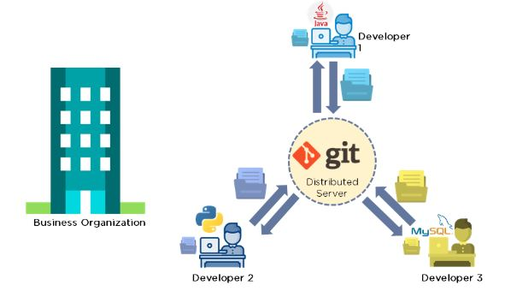

* Installation of Git

**Homebrew**

Install [homebrew](https://brew.sh/) if you don't already have it, then:  
$ brew install git

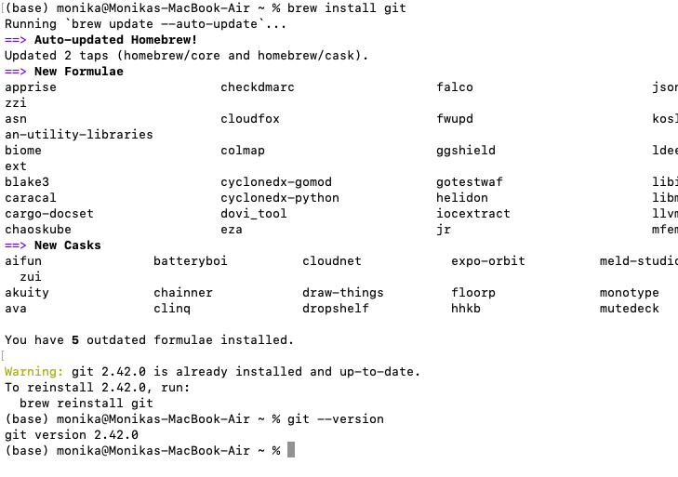

* Configuration of git

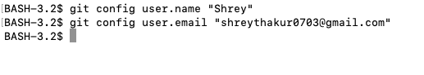

**PRACTICAL 2 :**

·       Git 3 stage Architecture

Many VCS’s use a two-tier architecture i.e a repository and a working copy. Git uses three-tier architecture i.e a working directory, staging area and local repository. The three stages of git can store different(or the same) states of the same code in each stage.

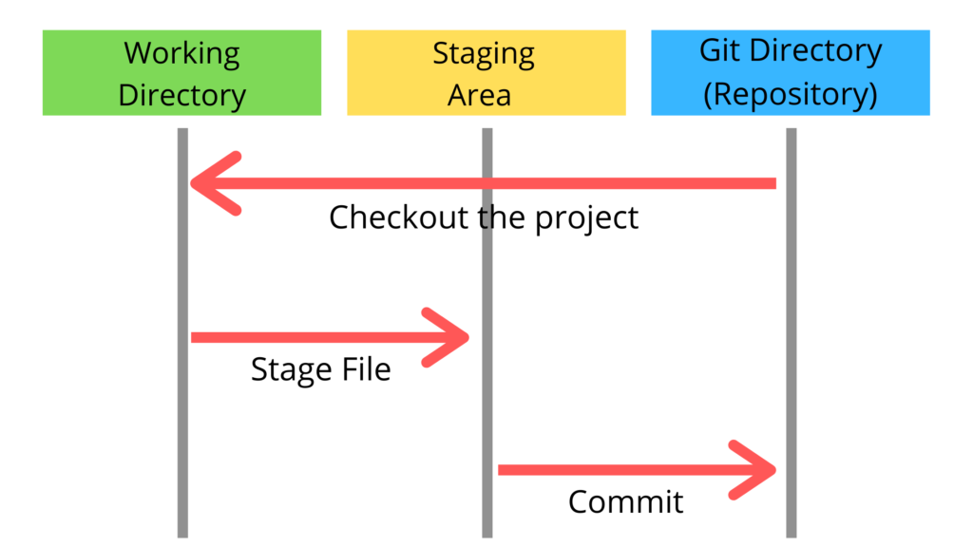

·       Generating SSH keys and agents on local machine

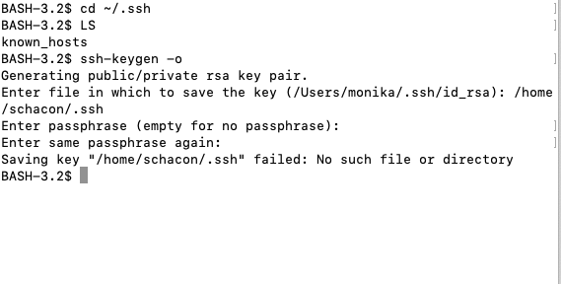

·       Adding origin(Github repository)



·       Git Tracking and use of basic commands – init, status and log

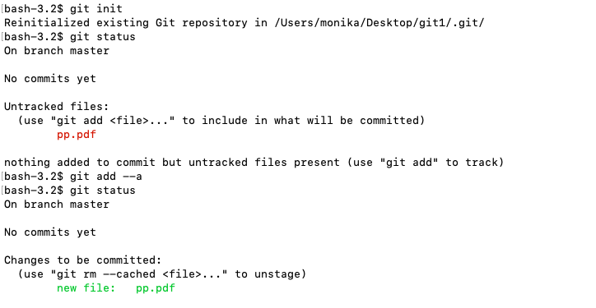

**PRACTICAL 3:  Application of Git commands – add, commit, push, pull**

**~git add**

Add a file to staging (Index) area:

$ git add Filename

Add all files of a repo to staging (Index) area:

$ git add .

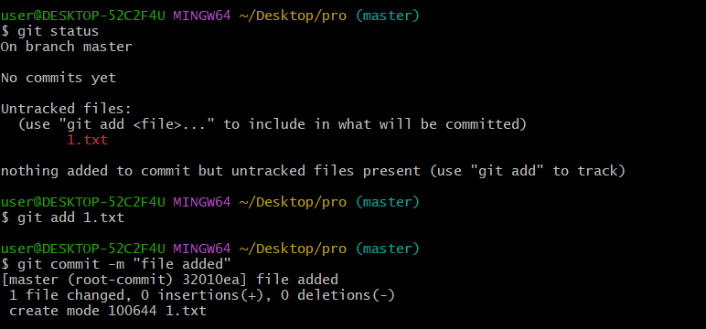

**~git commit**

**Record** or snapshots the file permanently in the version history **with a message**.

$ git commit -m " Commit Message"

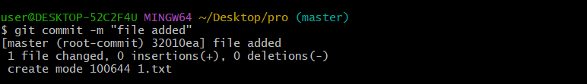

**git push**

Transfer the commits from your local repository to a remote server.

Push data to the remote server:

$git push -u origin master

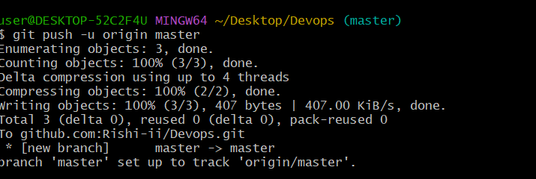

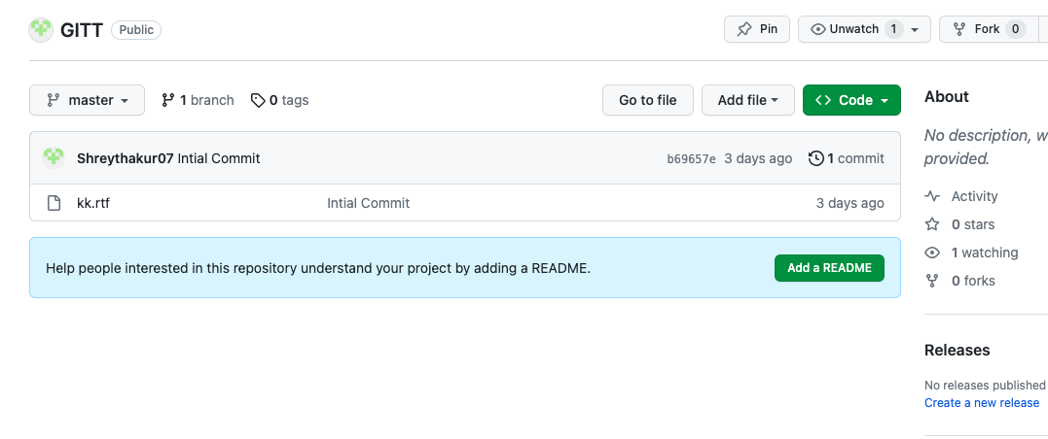

**PRACTICAL 4:     Perform the following in Git-  
·       Removal of Git repository/tracking**

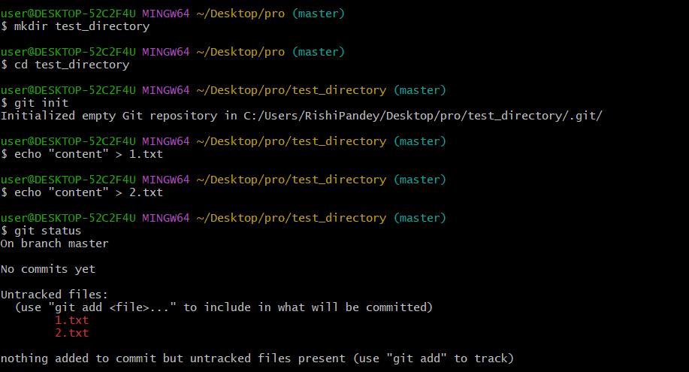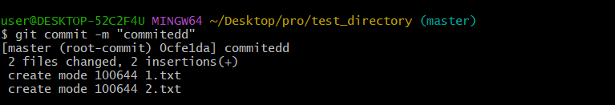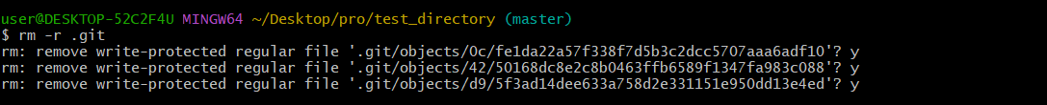

  
·

 git clone

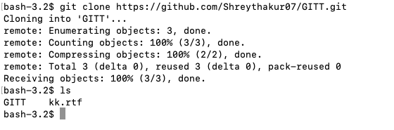  
·       .gitignore (scenario based usage(e.g.: a file/directory))

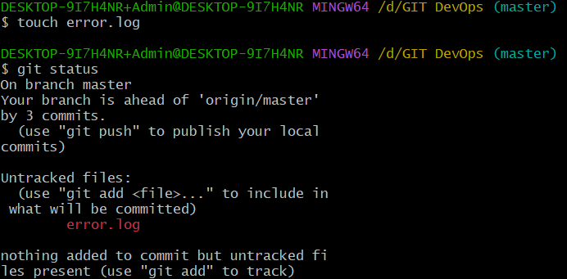

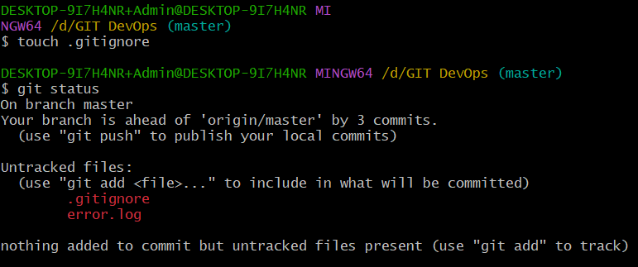

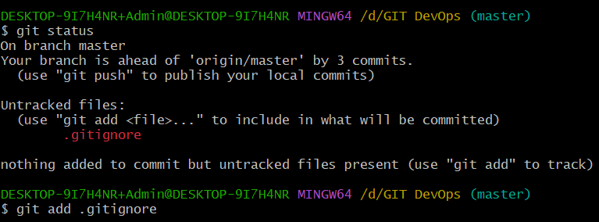

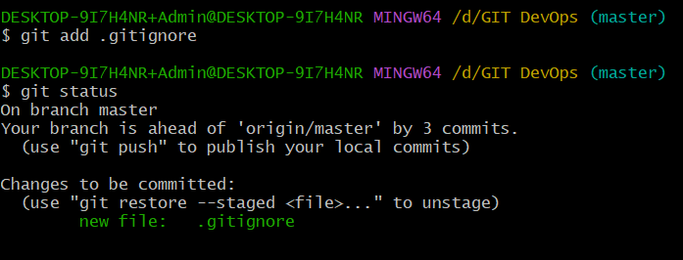

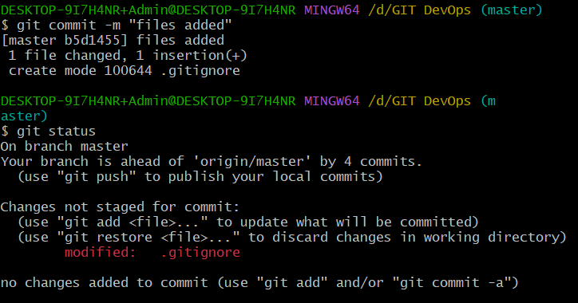

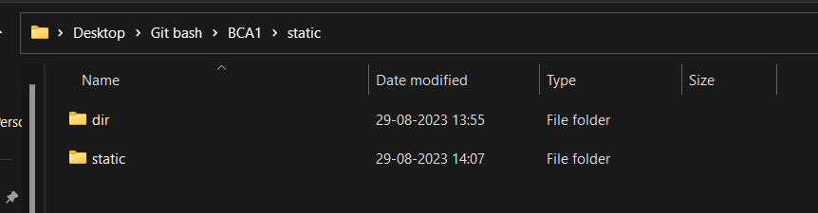

**Open the .gitignore file once again and modify it.**

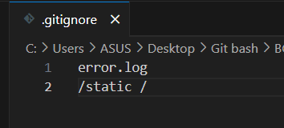

**Check the status again.**

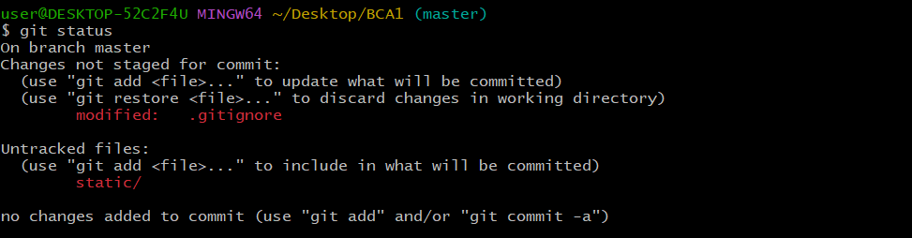

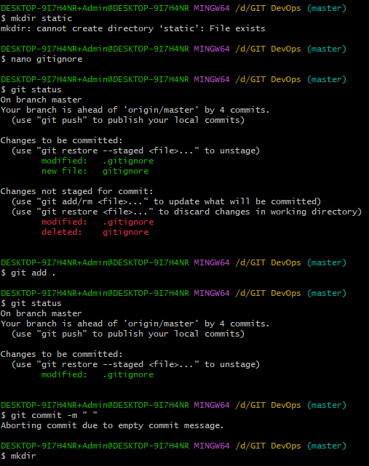

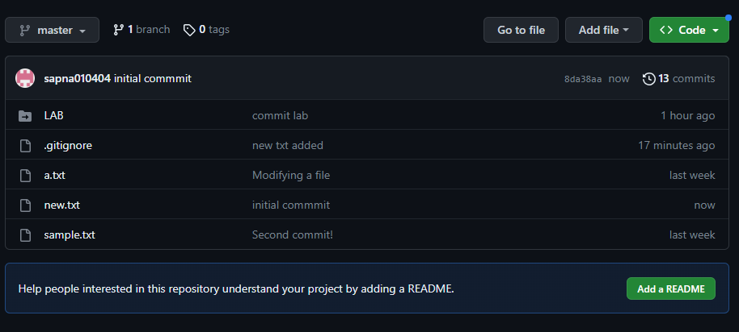

**Practical 5:     Show the use of -**  
·       git diff command

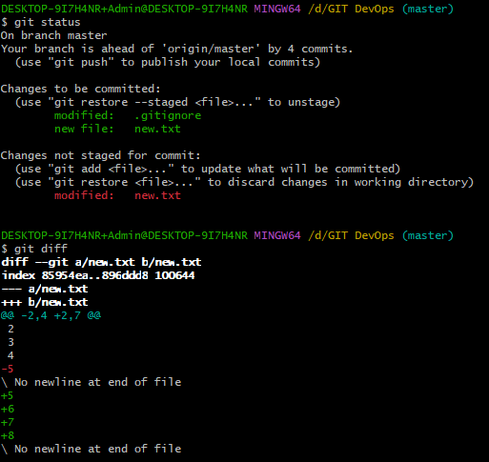

·       git difftool

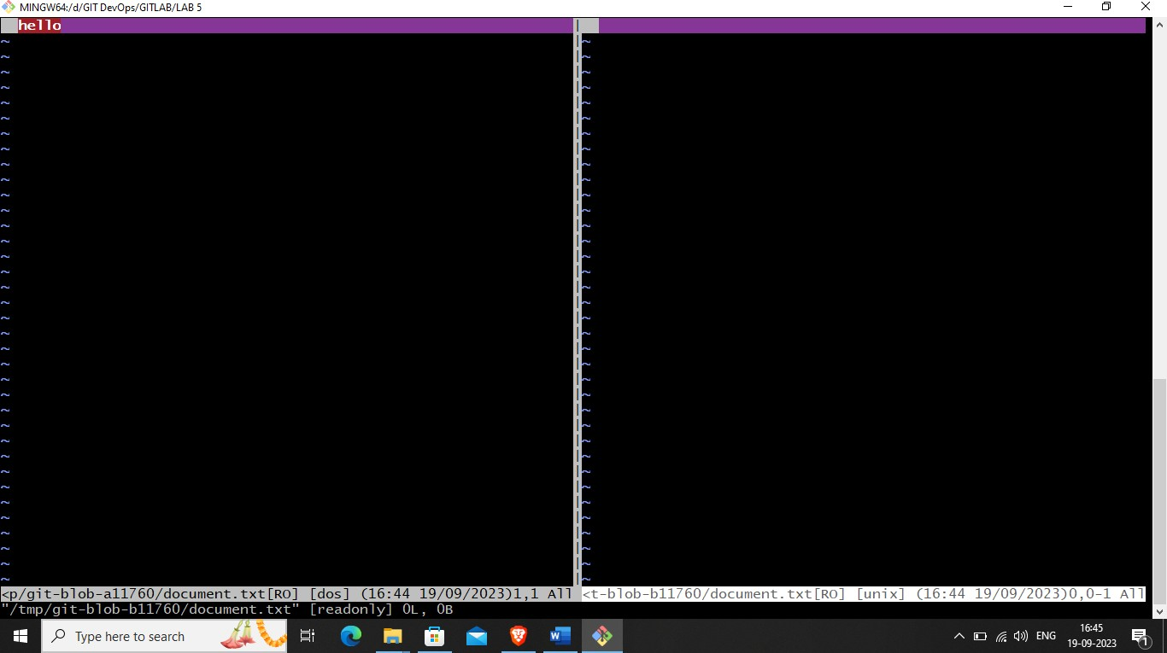

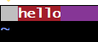

·       git restore command (to Restore files(e.g.: 2 out of total 5 files) from staging area that you don’t want to commit)

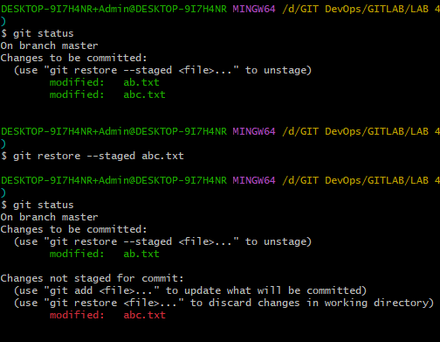

**PRACTICAL 6: Perform following code changes using Git commands (Undoing/ Reverting/ Resetting)**  
·       git checkout(undo uncommitted changes)

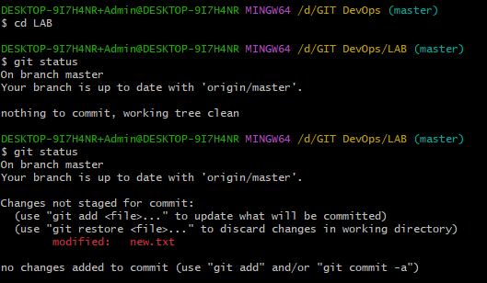

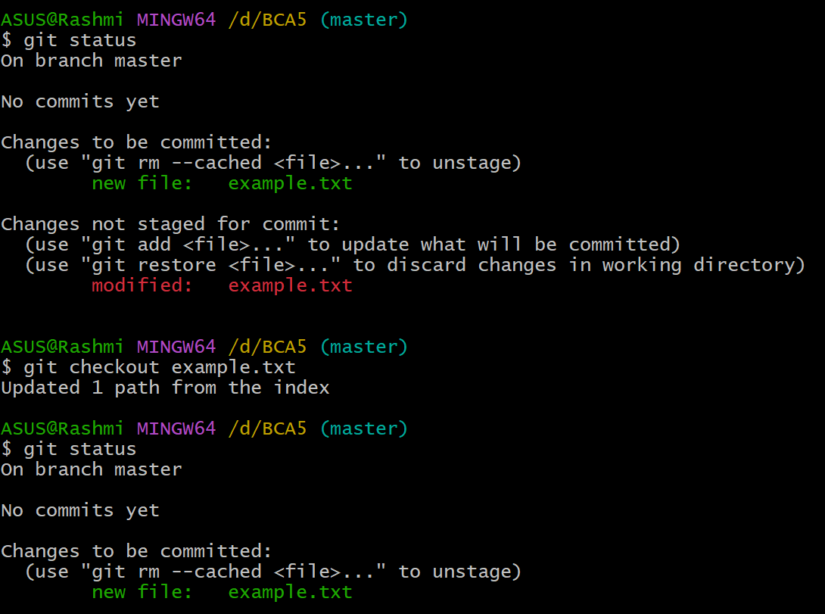

·       git revert (undo committed changes)

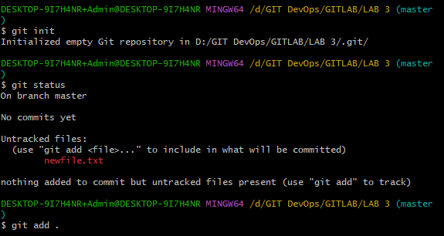

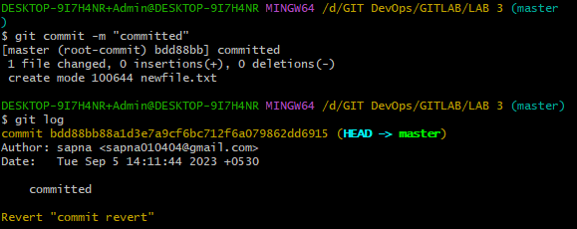

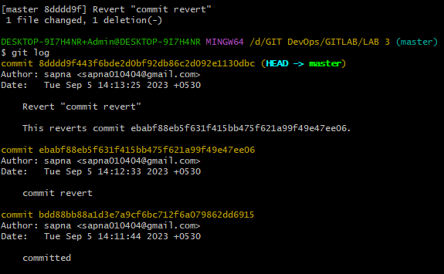

**git reset (resetting changes to a previous timestamp)**

The git reset command is used to undo the changes in your working directory and get back to a specific commit while discarding all the commits made after that one.

You can use multiple options along with git reset, but these are the main ones. Each one is used depending on a specific situation: git reset --soft, git reset --mixed, and git reset --hard

**Git reset --soft**

Aims to change the Head reference to a specific commit. add a file to the commit, we can move back using the --soft .

**Git reset --mixed**

This is the default argument for git reset. Running this command has two impacts:

(1) uncommit all the changes and (2) unstage them

**Git reset –hard**

When using the hard reset on a specific commit, it forces the HEAD to get back to that commit and deletes everything else after that. Considering this as a project which contains files like data, filtered data, and result.

**Scenario1: For git reset –soft**

▪ --soft  
By changing the HEAD, the files will go to the area where changes were made and need to be committed. ( Working+staging)

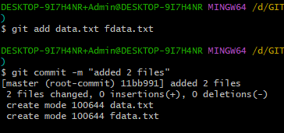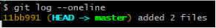

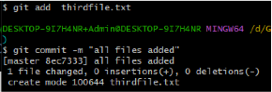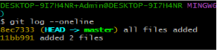

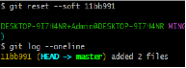

**PRACTICAL 7: Git branching**

Branching in Git is a powerful feature that allows you to work on multiple independent lines of development within the same repository. Each branch represents a separate line of development and can have its own set of commits, changes, and history.

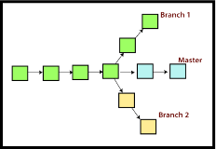

 Adding branches

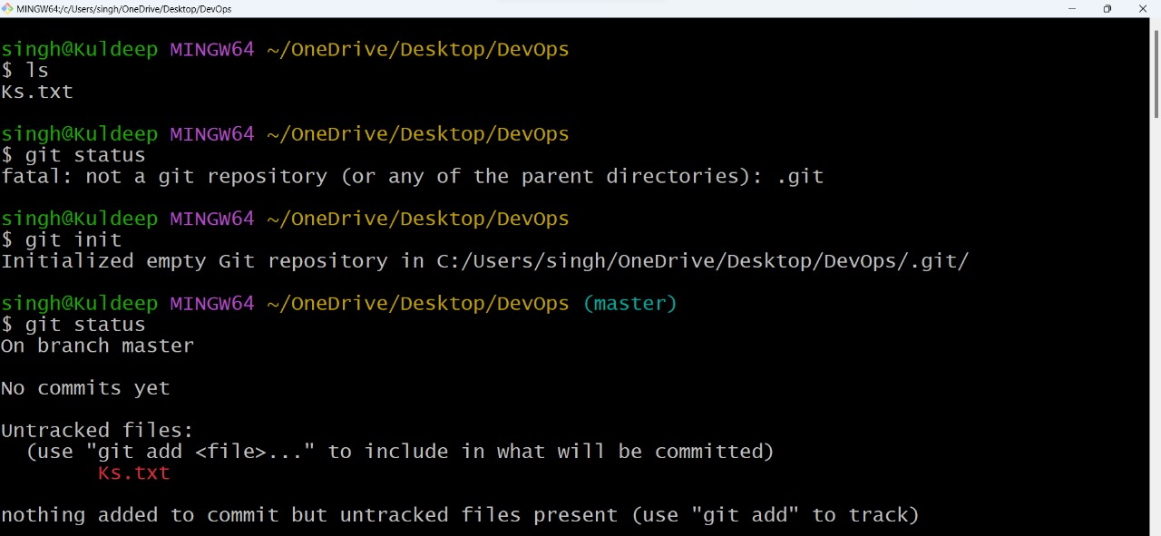

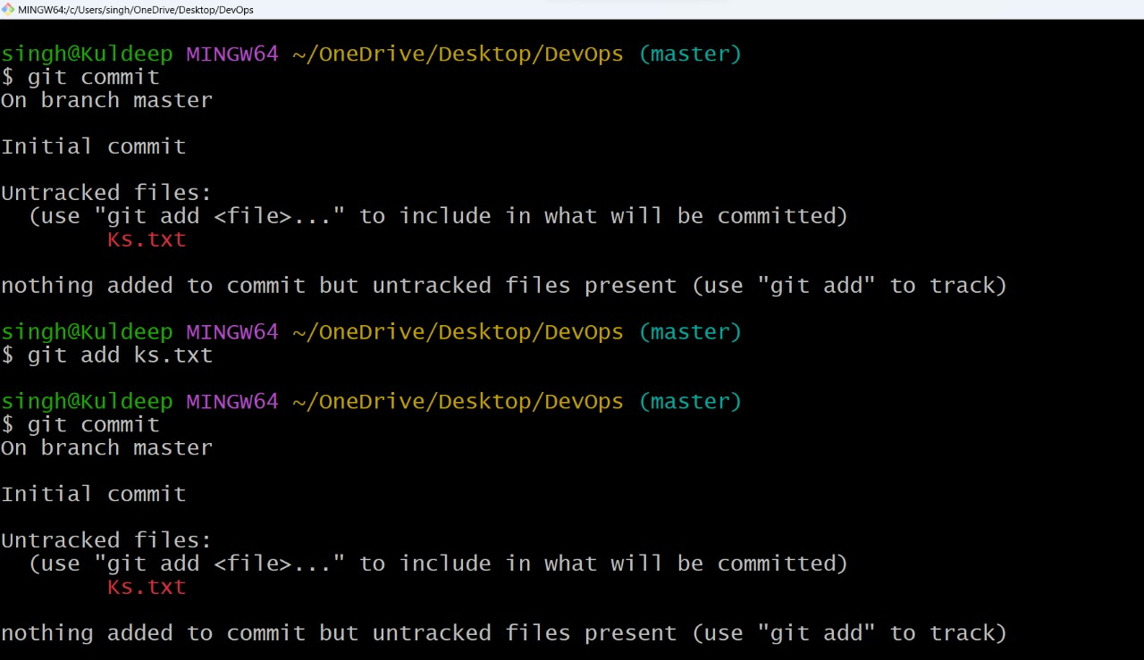

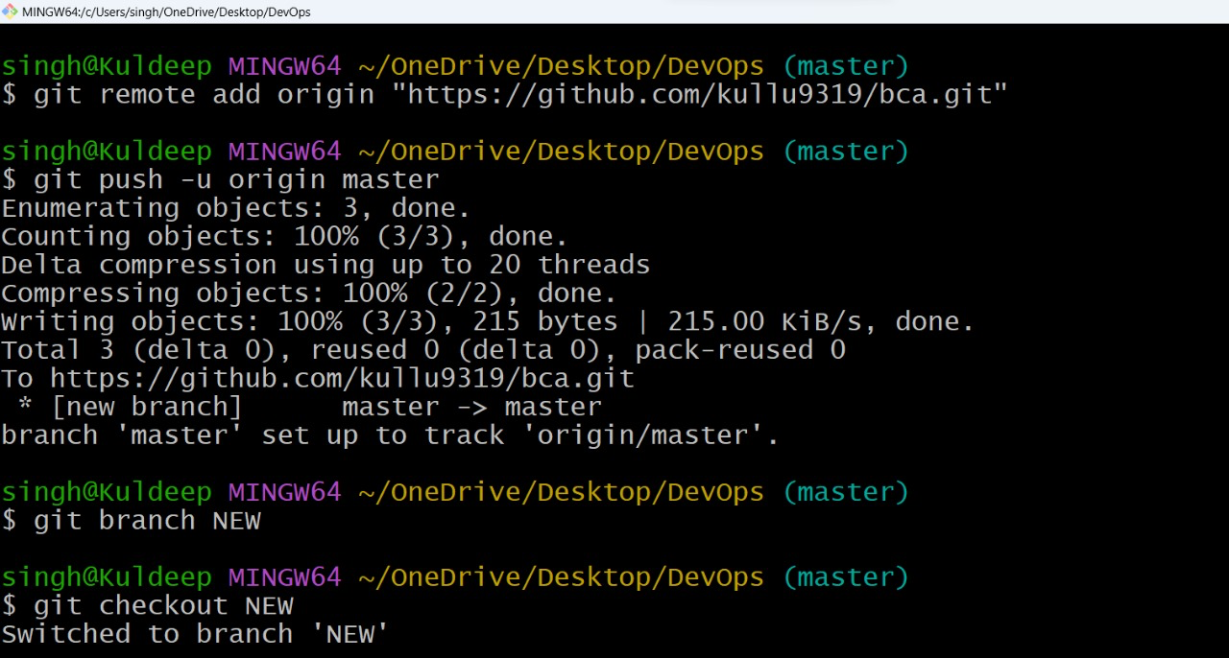

·       Switching branches

  
·       Merging branches

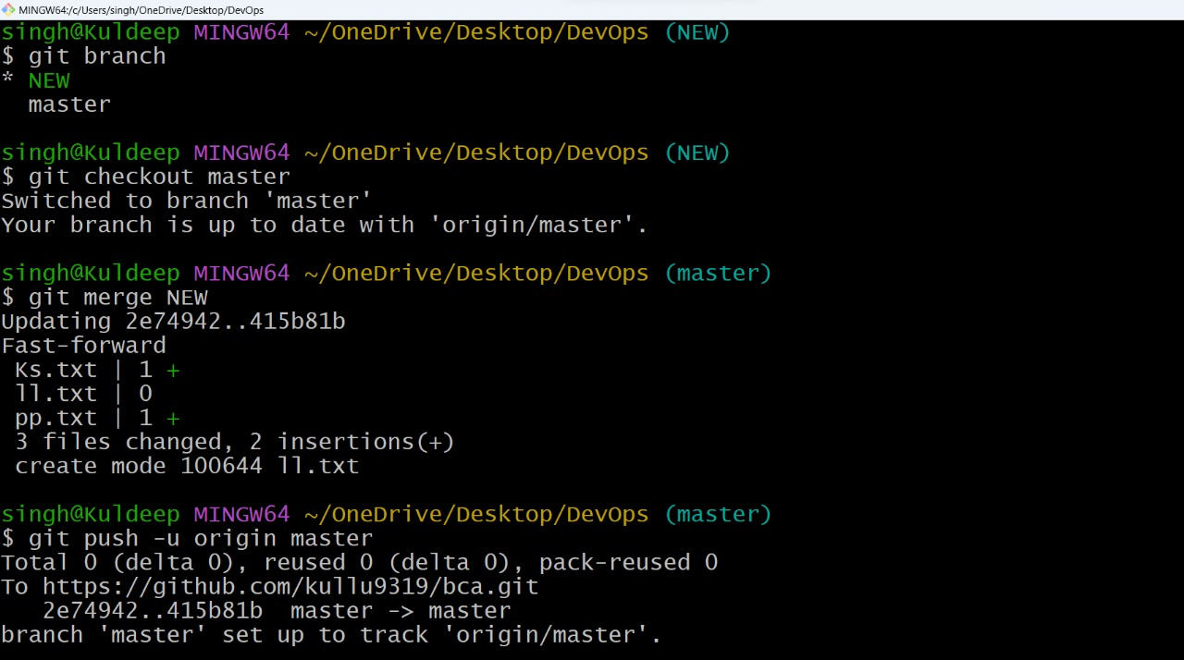  
·       Deleting branches(from git as well as github too)

  
 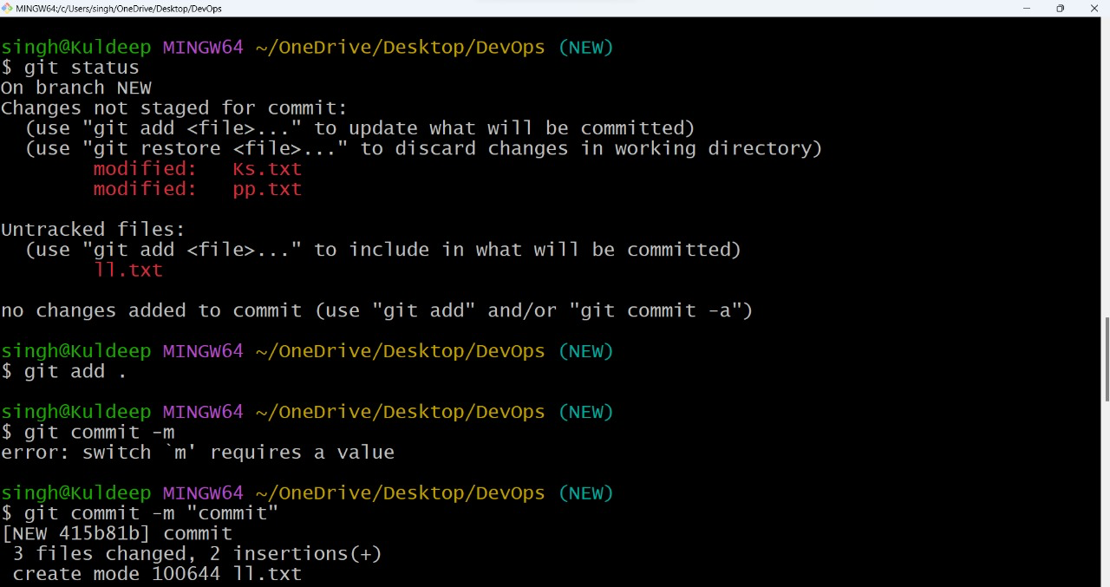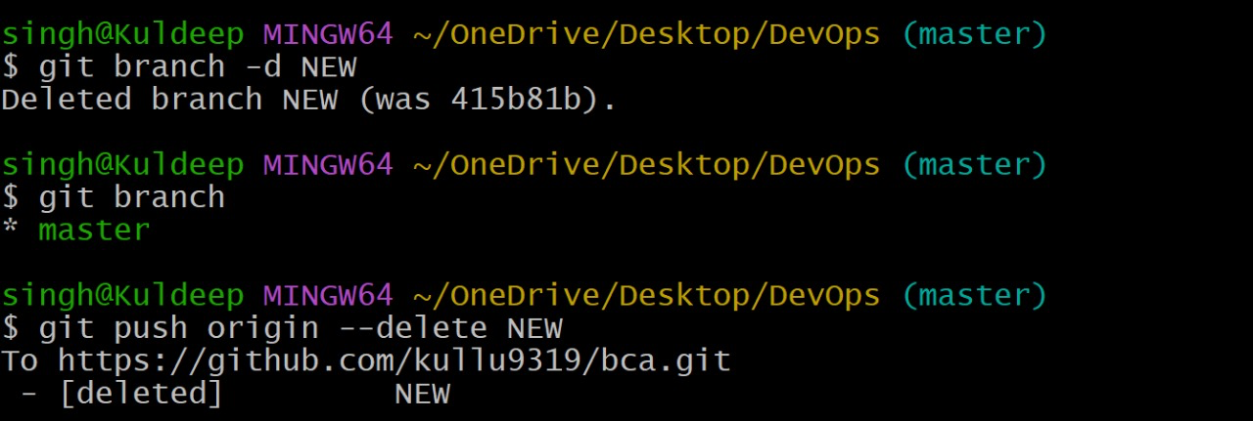

Git cherry-pick

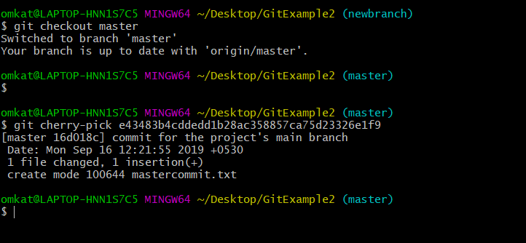

• git tag

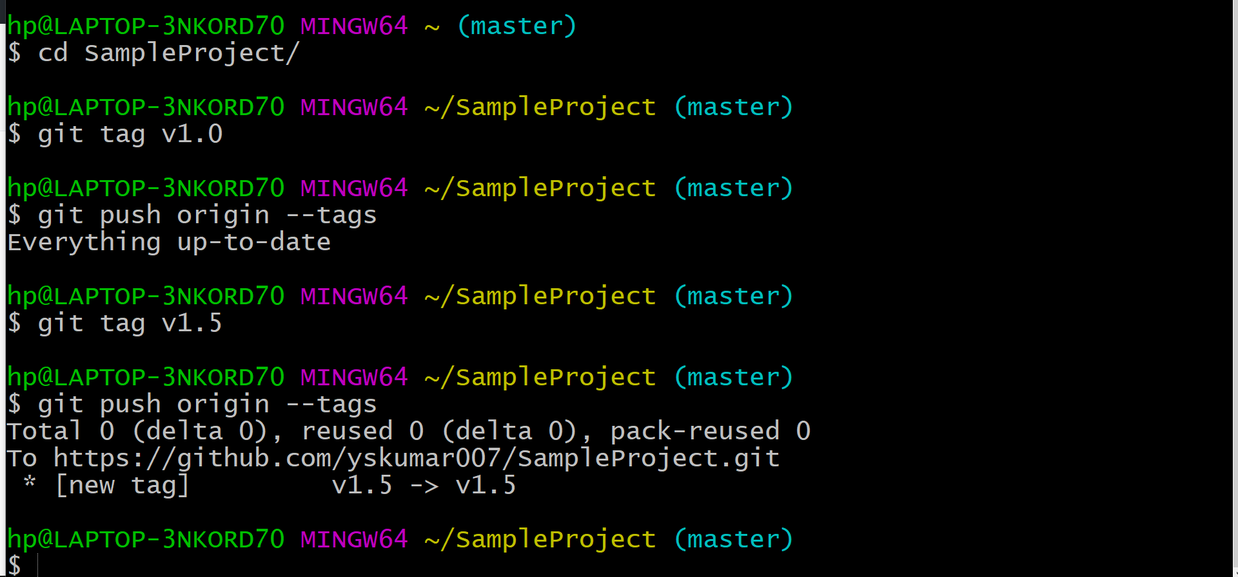

• git upstream and downstream

|  |  |
| --- | --- |
| **●** | Upstream: Refers to the original repository from which a clone was made. It |
|  | represents the source or parent repository. |
| **●** | Downstream: Refers to forks or clones of a repository. If you fork a repository, |
|  | your fork is considered downstream from the original repository. |

**PRACTICAL 8 : Usage of git stash(for temporary commits)**

**git stash**

the stash's meaning is "**store something safely in a hidden place**." The sense in Git is also the same for stash; Git temporarily saves your data safely without committing.

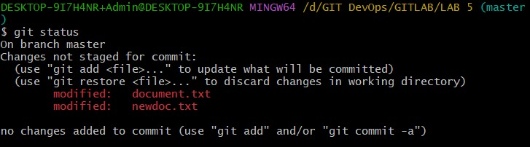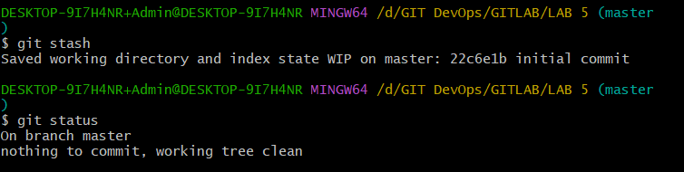

## Git stash list

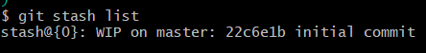

**Git stash show**

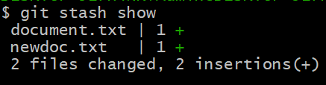

## Git stash show -p

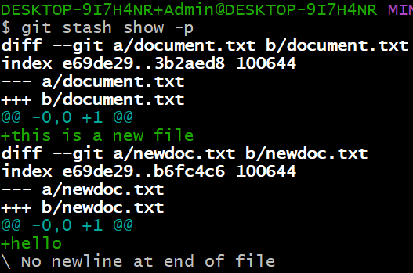

**Git stash pop**

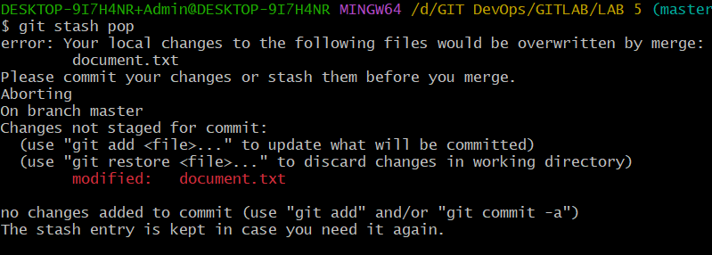

## Git stash save <message>

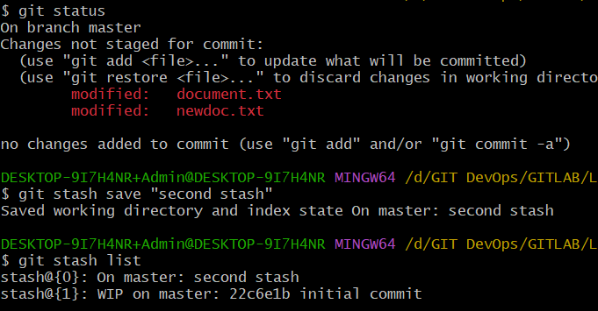

**Git stash drop**

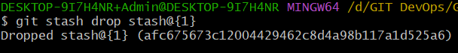

## Git stash clear

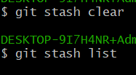

**Rename a file: mv**

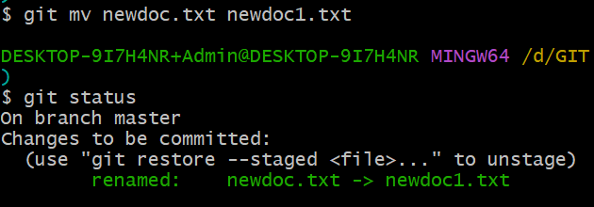

## Move a file to a folder.

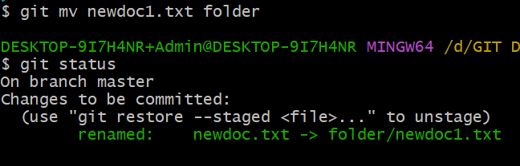

**Check HEAD:**

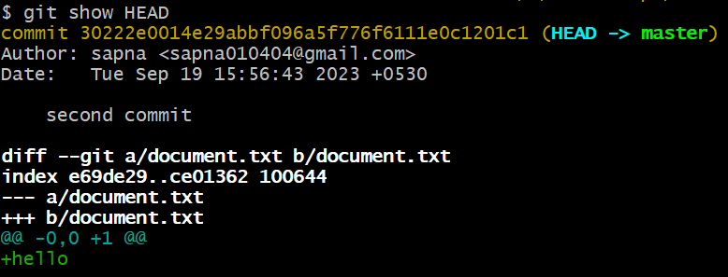

## Git checkout <commit_ID>:

s

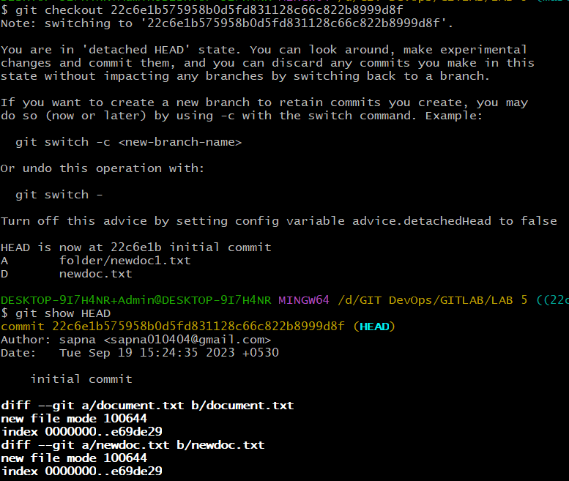

## Git checkout master

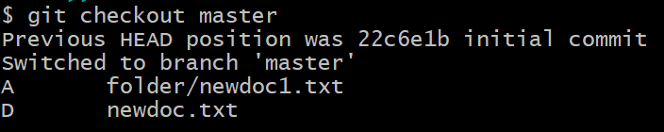

**PRACTICAL. 9 :**

**Head**

A git HEAD is simply a pointer that points to a specific version or state of a git repository. It can point to either ***the latest commit*** 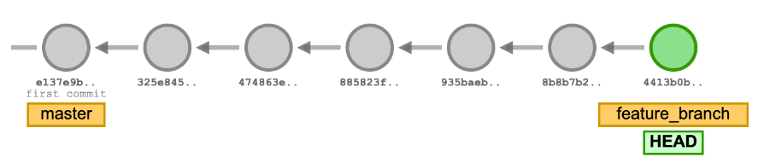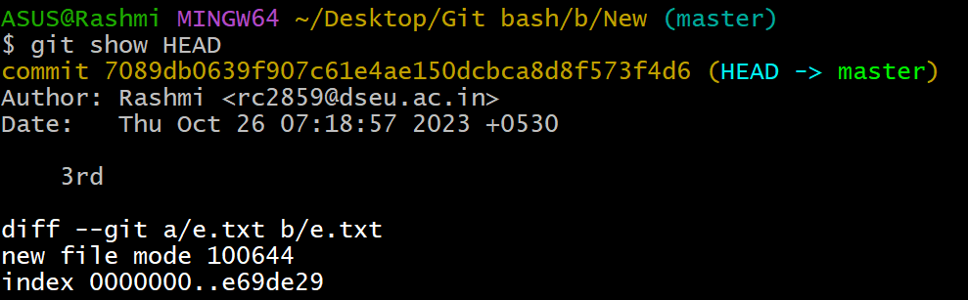

**Detached head**

When you are in a *git detached HEAD*

state, you are not on any branch. The HEAD



references or points to a commit directly instead of a branch.

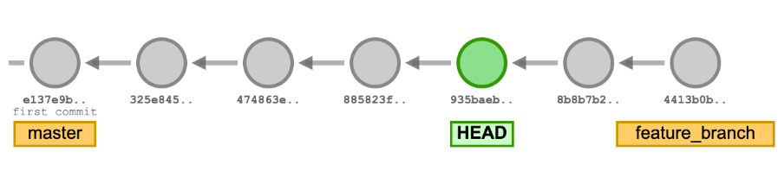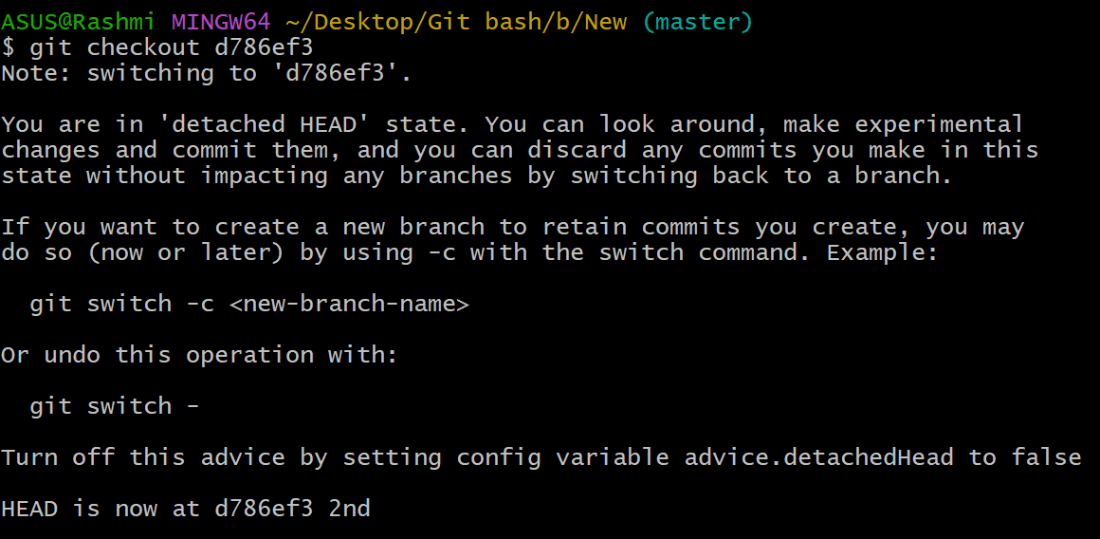

**PRACTICAL 10 :**

* Rebasing in Git is a process of integrating a series of commits on top of another base tip. It takes all the commits of a branch and appends them to the commits of a new branch.

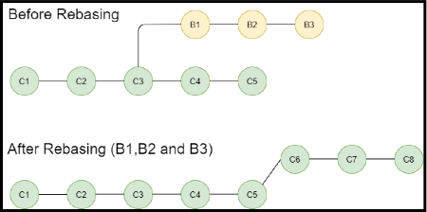

* git reset –hard
* **Suppose there are two branches master and New. Step1: In master branch, Commit some files.**
* 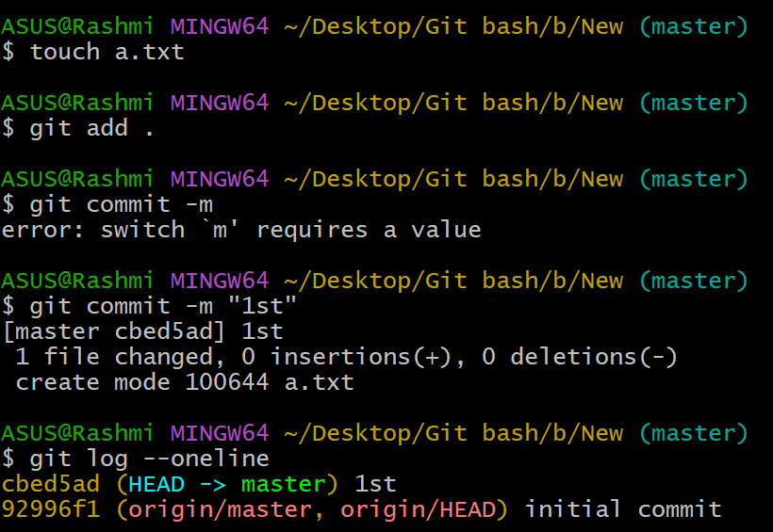
* **1st Commit (Master branch)**
* 
* **Step2: Checkout to New branch and add some files.**
* **Step 3: Now checkout to master branch again, and add some files there too.**
* 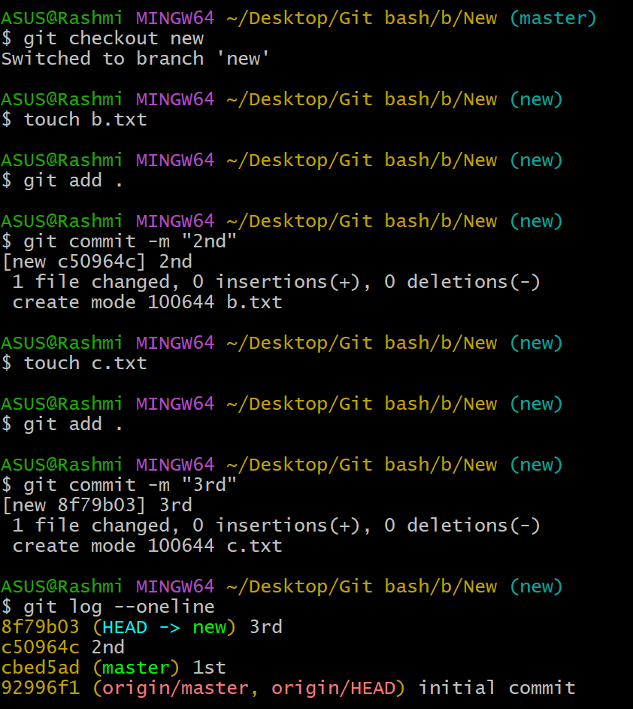
* **2nd Commit (New branch)**
* **4th Commit (Master branch)**
* **3rd Commit (New branch)**
* 
* **Step4: By using rebase command, we will combine the commits.**
* 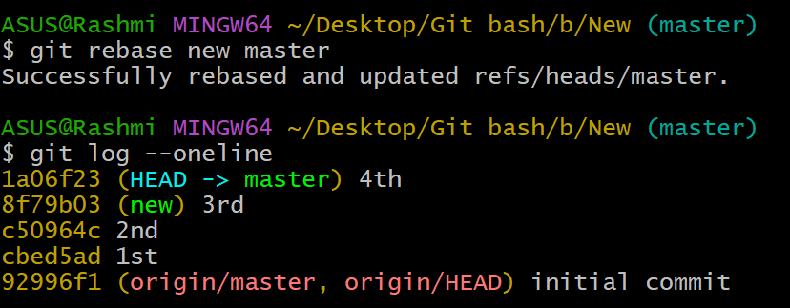
* 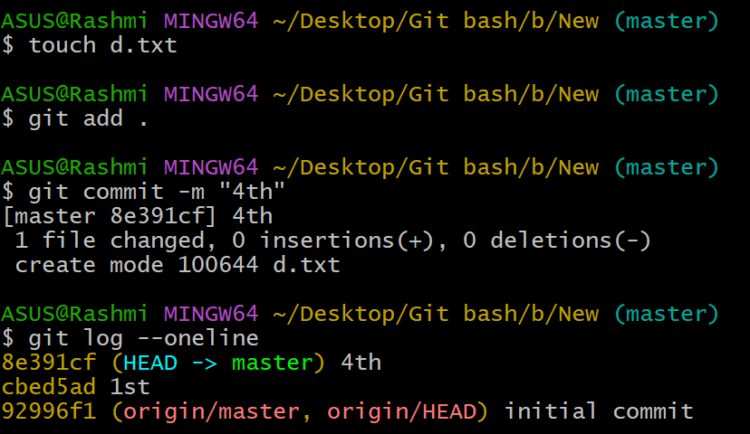

**Git squash**

* To "squash" in Git means to combine multiple commits into one.
* **By using this command, an editor will open**
* **In this editor, we will replace the pick command with squash command.**

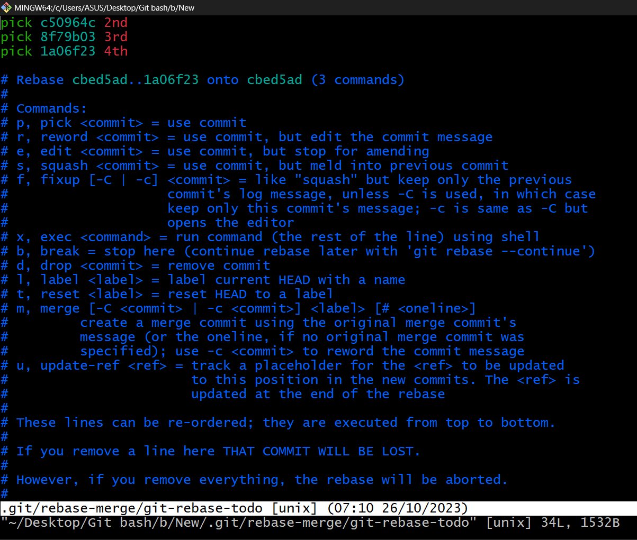

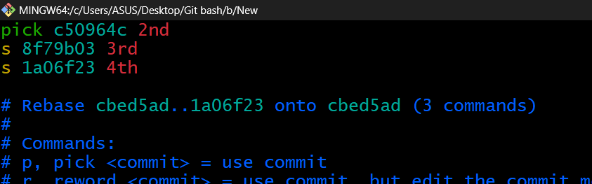

**We will save these changes.**

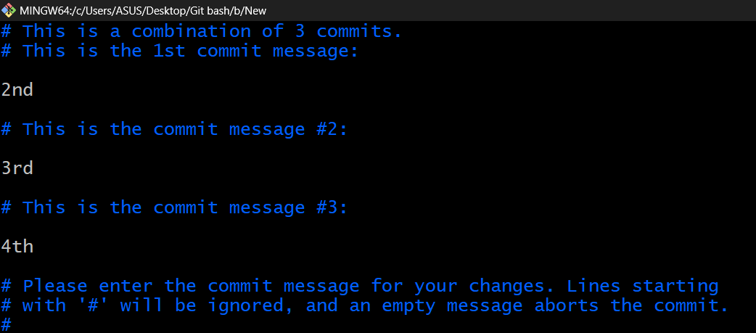

* **Next, we removed the commit messages from the editor.**
* 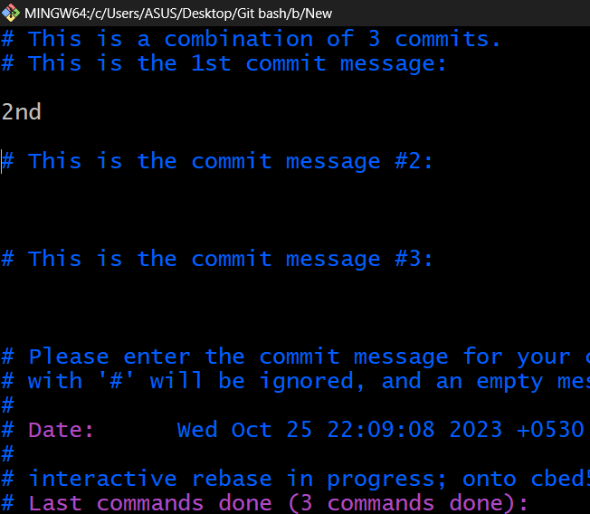

**We will save these changes and exit from editor.**

* 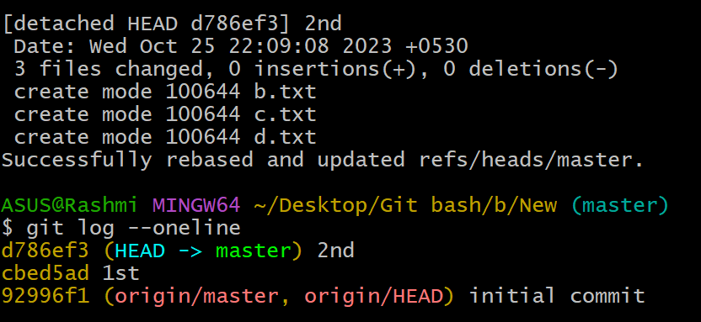

**Here we successfully used the squash command to combine commits.**

**Practical 11: Background study, Installation and configuration of Jenkins**

Jenkins is an open source automation tool written in Java programming language that allows continuous integration.

Jenkins **builds** and **tests** our software projects which continuously making it easier for developers to integrate changes to the project, and making it easier for users to obtain a fresh build.

It also allows us to continuously **deliver** our software by integrating with a large number of testing and deployment technologies.

Jenkins offers a straightforward way to set up a continuous integration or continuous delivery environment for almost any combination of languages and source code repositories using pipelines, as well as automating other routine development tasks.

With the help of Jenkins, organizations can speed up the software development process through automation. Jenkins adds development life-cycle processes of all kinds, including build, document, test, package, stage, deploy static analysis and much more.

Jenkins achieves CI (Continuous Integration) with the help of plugins. Plugins is used to allow the integration of various DevOps stages. If you want to integrate a particular tool, you have to install the plugins for that tool. For example: Maven 2 Project, Git, HTML Publisher, Amazon EC2, etc.

**For example:** If any organization is developing a project, then **Jenkins** will continuously test your project builds and show you the errors in early stages of your development.

**Work Flow:**

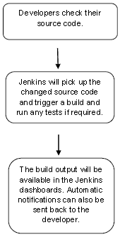

INSTALLATION OF JENKING:

### **1. Install Java Development Kit (JDK)**

* Download [JDK 8](https://www.oracle.com/technetwork/java/javase/downloads/jdk8-downloads-2133151.html) and choose windows 32-bit or 64-bit according to your system configuration. Click on "accept the license agreement."

### **2. Set the Path for the Environmental Variable for JDK**

* Go to System Properties. Under the "Advanced" tab, select "Environment Variables."
* Under system variables, select "new." Then copy the path of the JDK folder and paste it in the corresponding value field. Similarly, do this for JRE.
* Under system variables, set up a bin folder for JDK in PATH variables.
* Go to command prompt and type the following to check if [Java](https://www.simplilearn.com/best-java-programs-article) has been successfully installed

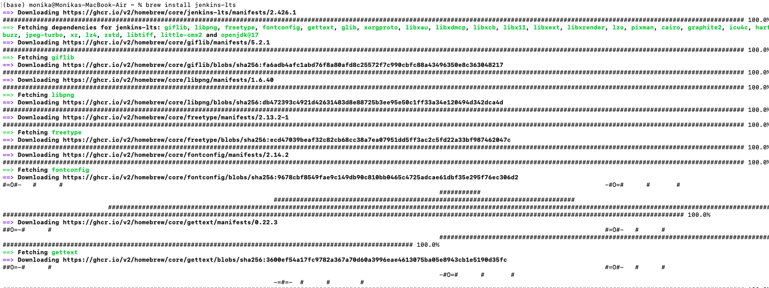

### **3. Download and Install Jenkins**

* [Download Jenkins](https://jenkins.io/download/). Under LTS, click on windows.
* After the file is downloaded, unzip it. Click on the folder and install it. Select "finish" once done.



### **4. Run Jenkins on Localhost 8080**

* Once Jenkins is installed, explore it. Open the web browser and type "localhost:8080".
* Enter the credentials and log in. If you install Jenkins for the first time, the dashboard will ask you to install the recommended plugins. Install all the recommended plugins.

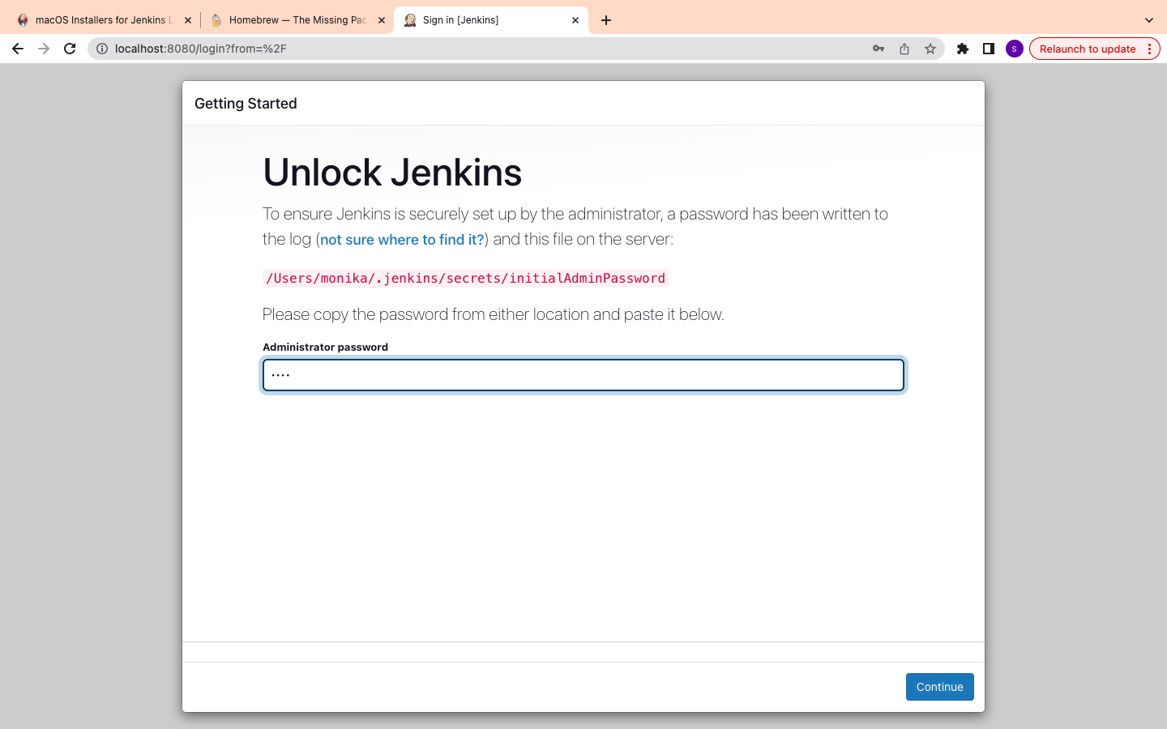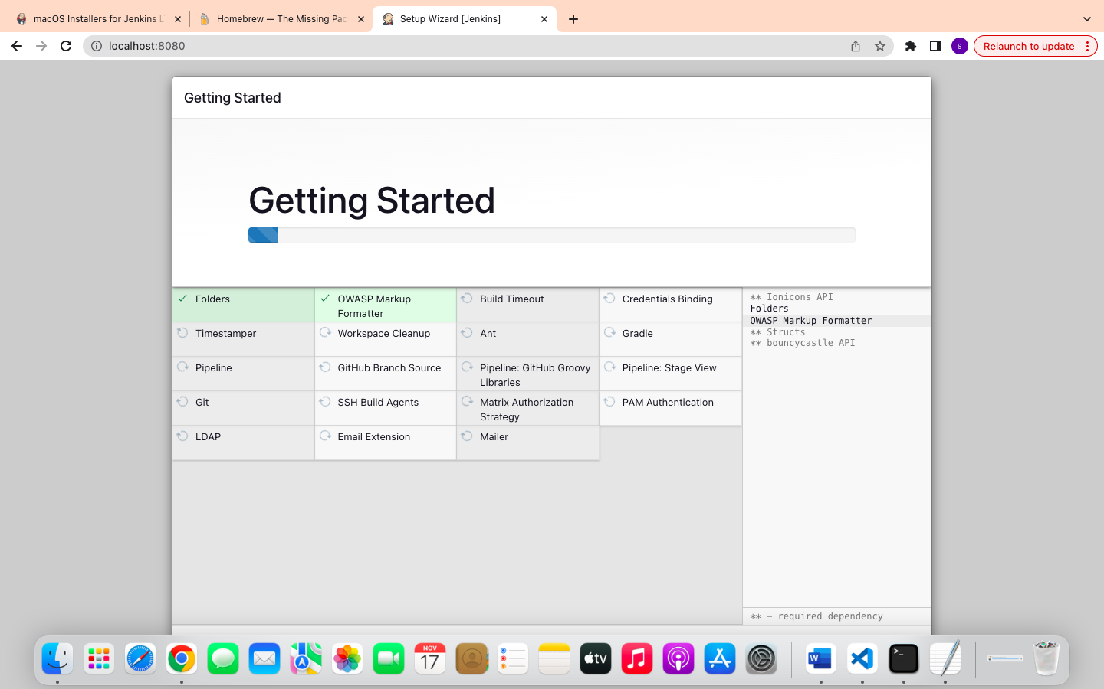

### **5. Jenkins Server Interface**

* New Item allows you to create a new project.
* Build History shows the status of your builds.
* Manage System deals with the various configurations of the system.

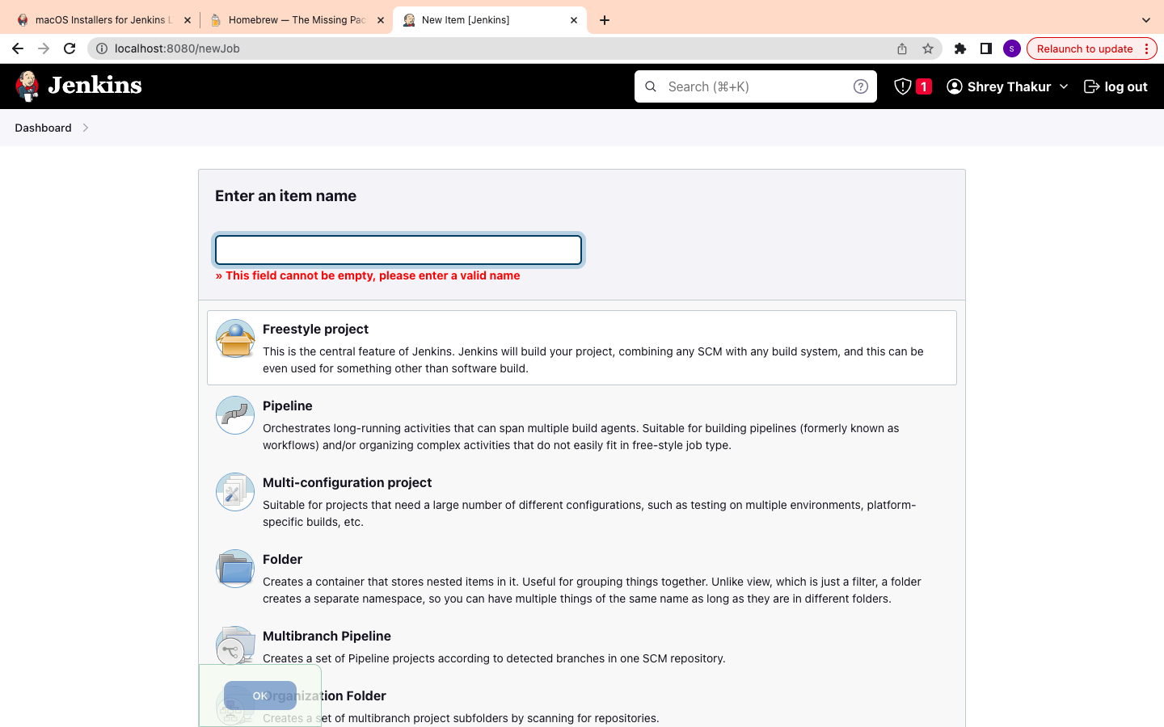

### **6. Build and Run a Job on Jenkins**

* Select a new item (Name - Jenkins_demo). Choose a freestyle project and click Ok.
* Under the General tab, give a description like "This is my first Jenkins job." Under the "Build Triggers" tab, select add built step and then click on the "Execute Windows" batch command.
* In the command box, type the following: echo "Hello... This is my first Jenkins Demo: %date%: %time% ". Click on apply and then save.
* Select build now. You can see a building history has been created. Click on that. In the console output, you can see the output of the first Jenkins job with time and date

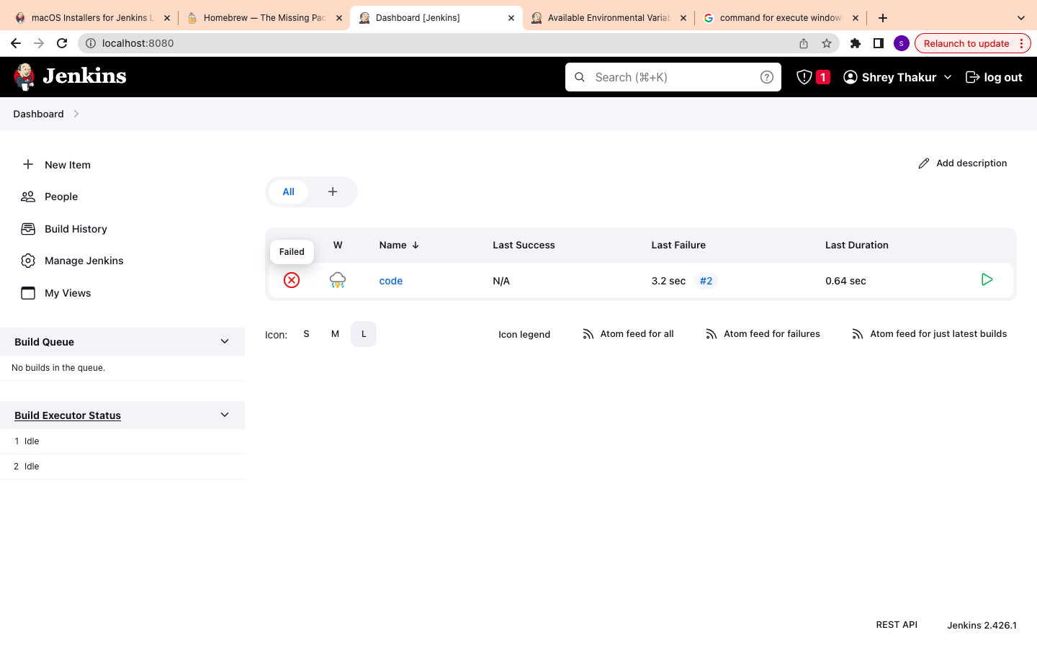

PRACTICAL 12 : Perform following in Jenkins(with snapshots of each step):-

• Design Jenkins Architecture

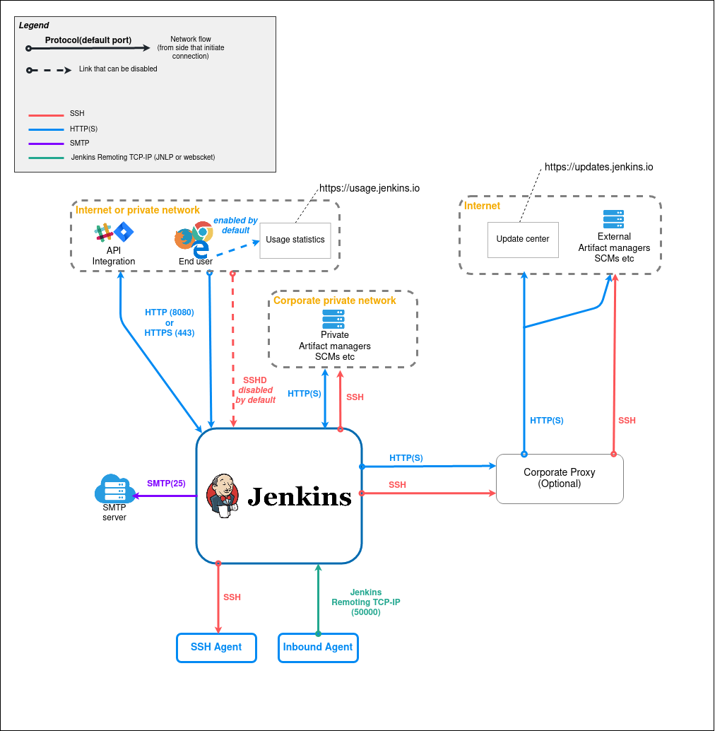

• Creating Jobs in Jenkins(e.g. : with status- success, partial, failure)

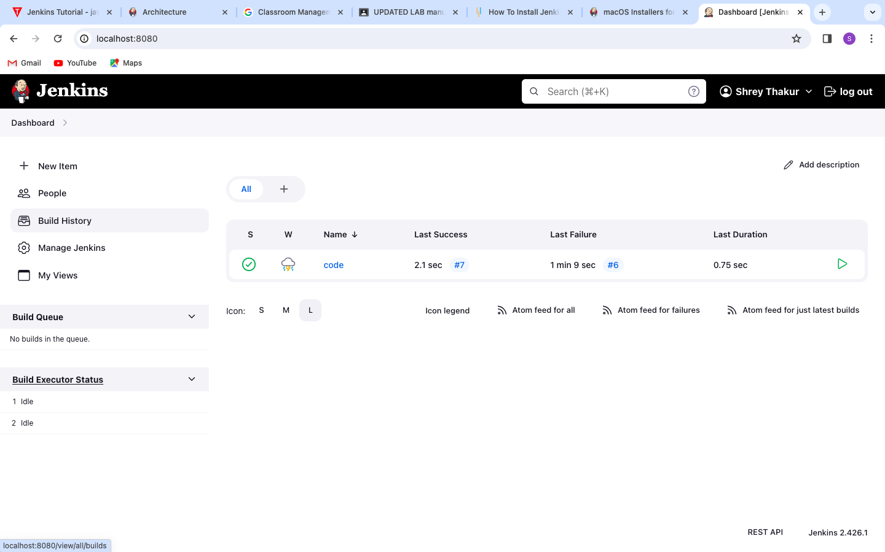

• Adding slave nodes to Jenkins

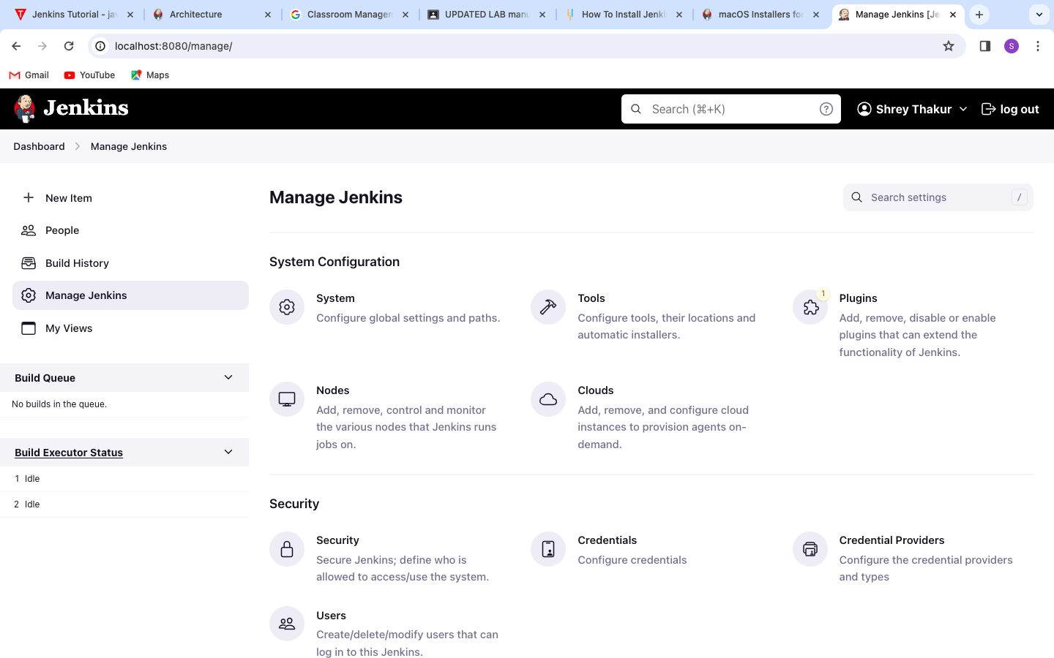

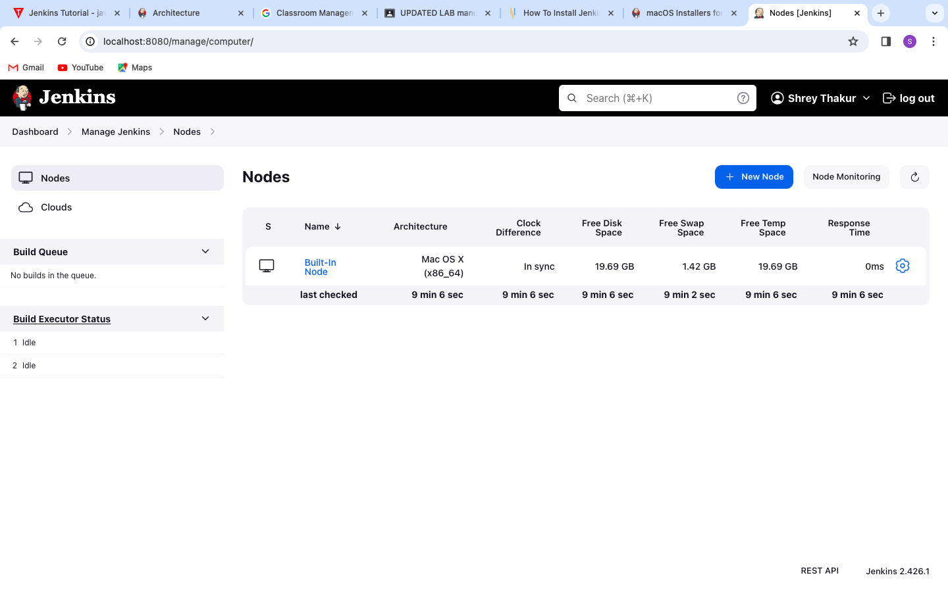

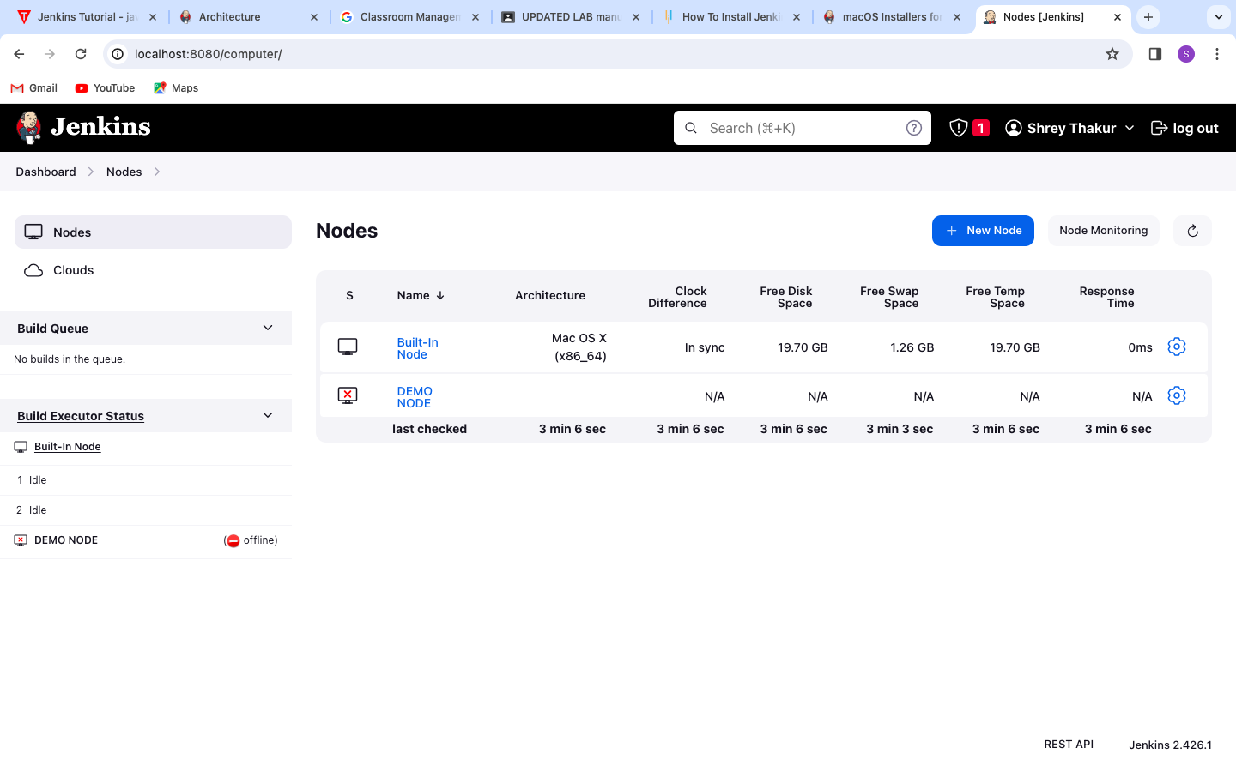

• Fetching content from github in Jenkins

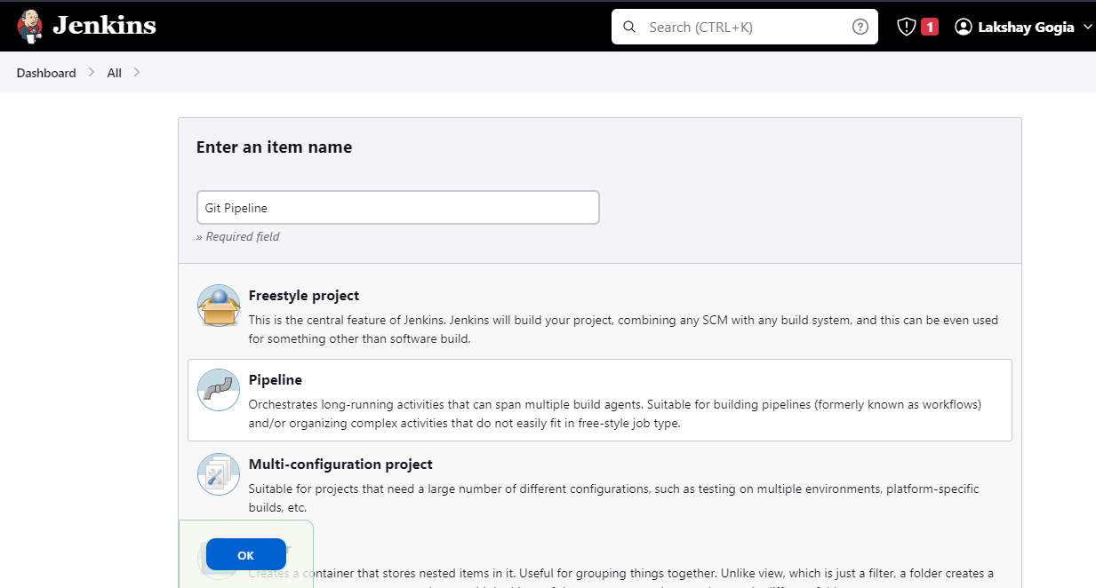

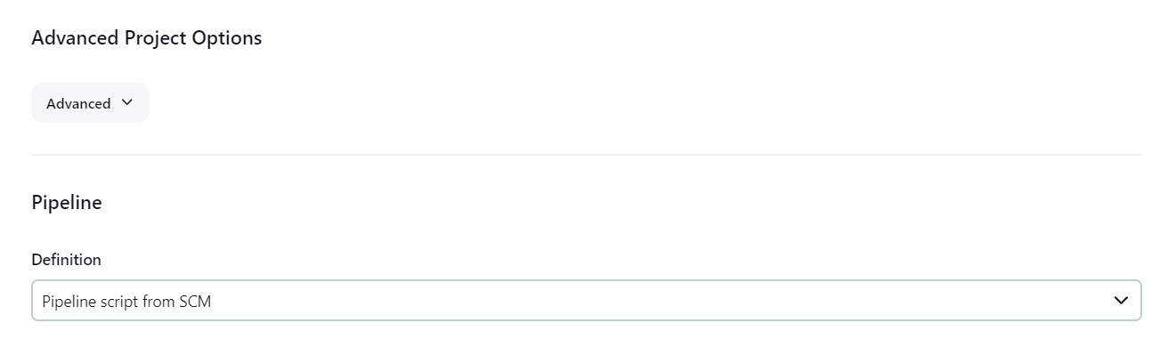

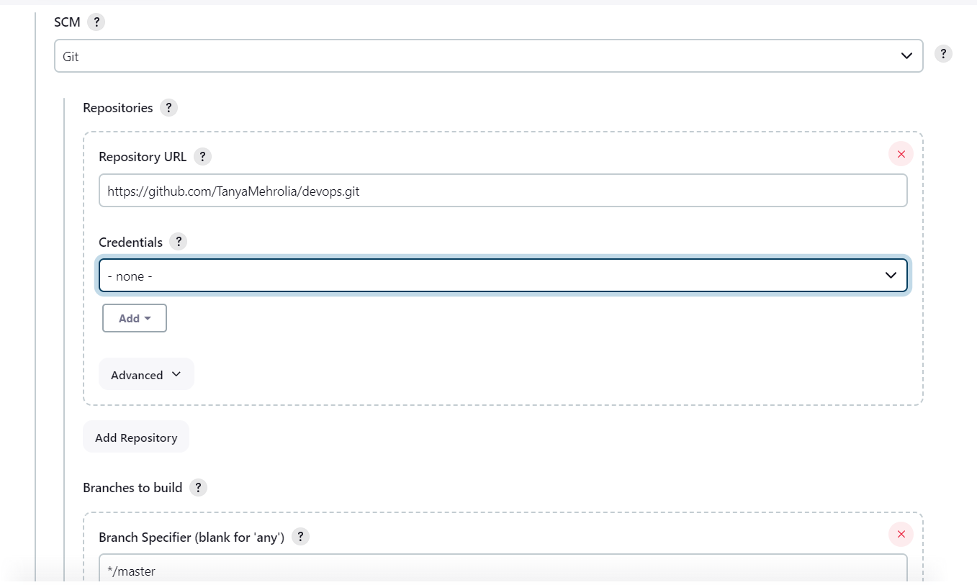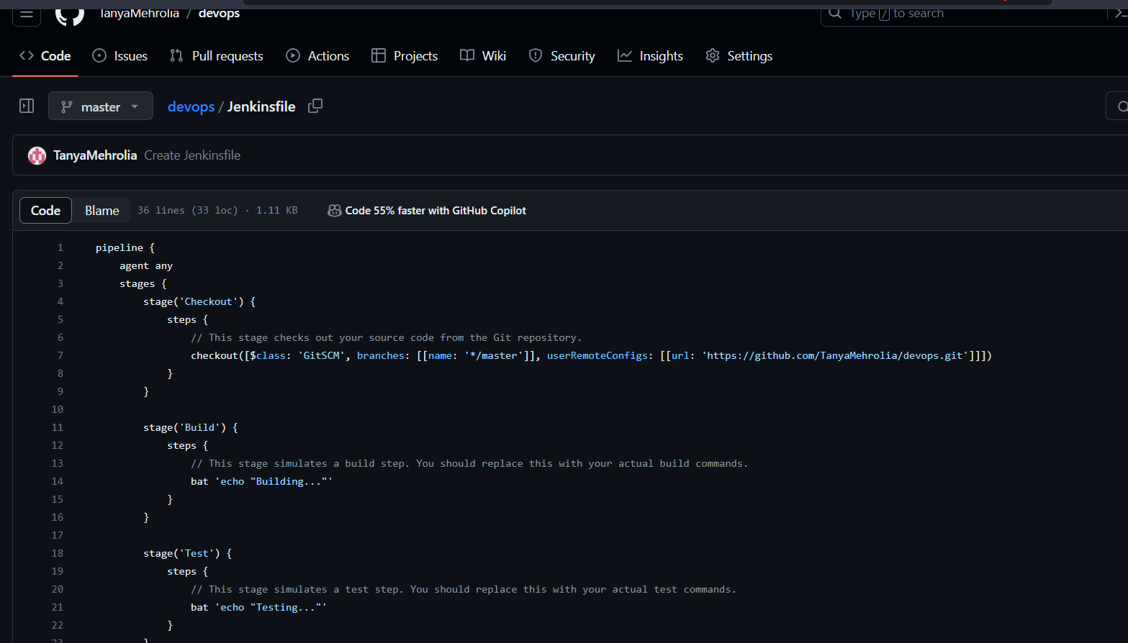

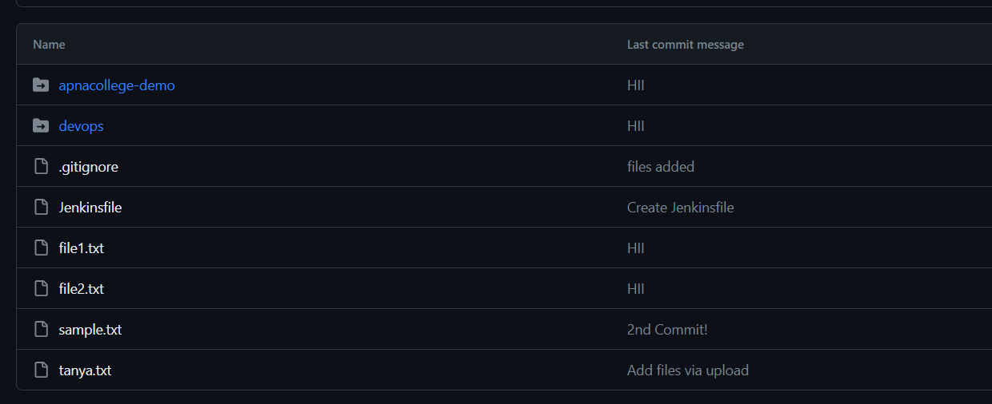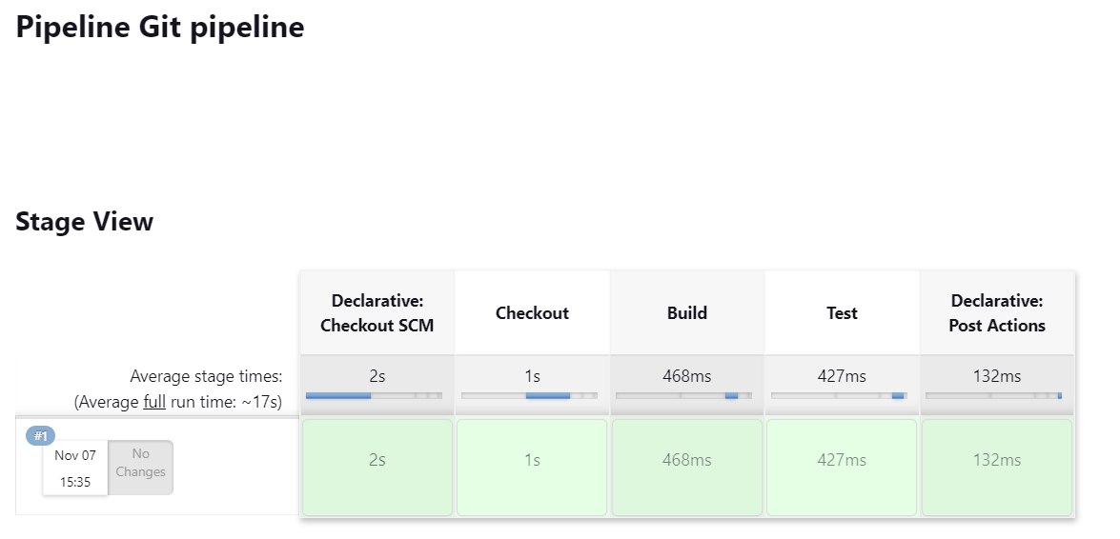

• Build the pipeline of fetched jobs from github in/using Jenkins

**Step 1: Create a Jenkins Job**

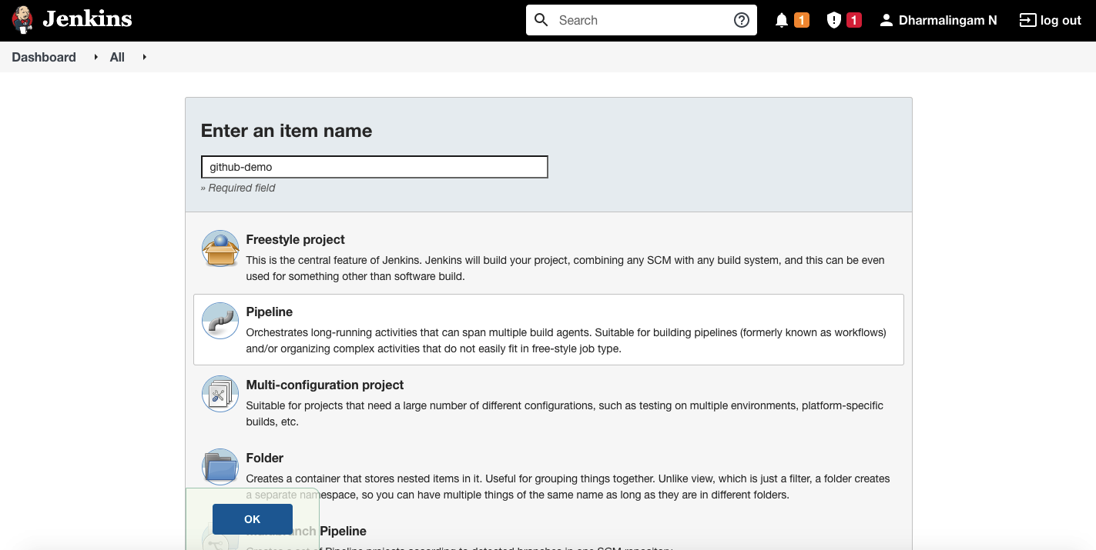

**Step 2: Configure GitHub Hook Trigger**

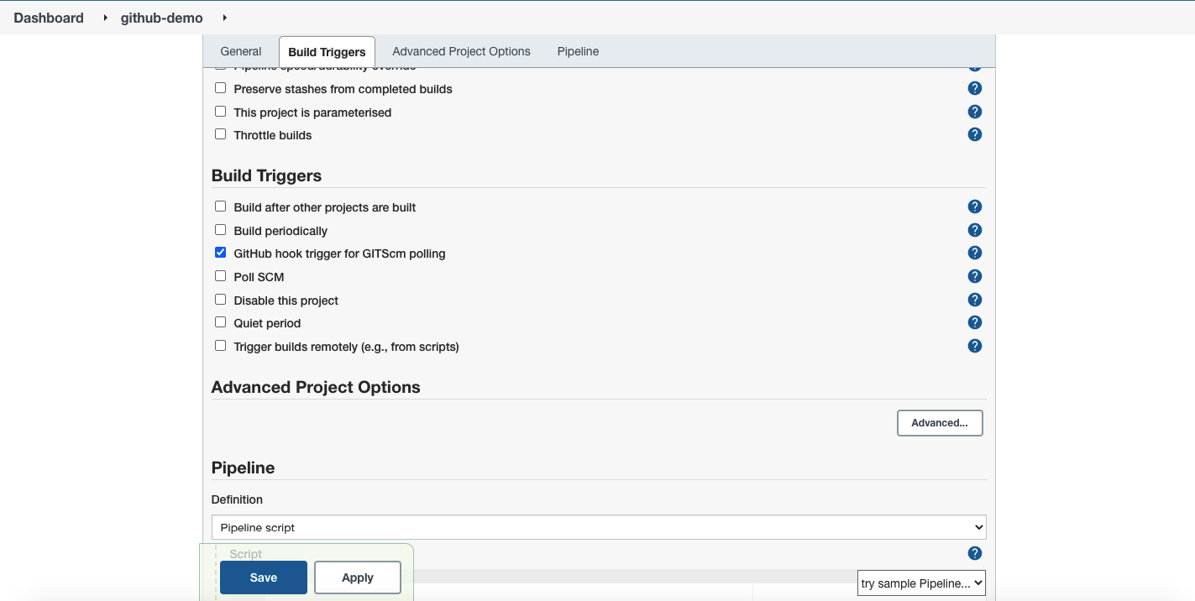

**Step 3: Create a GitHub Repository**

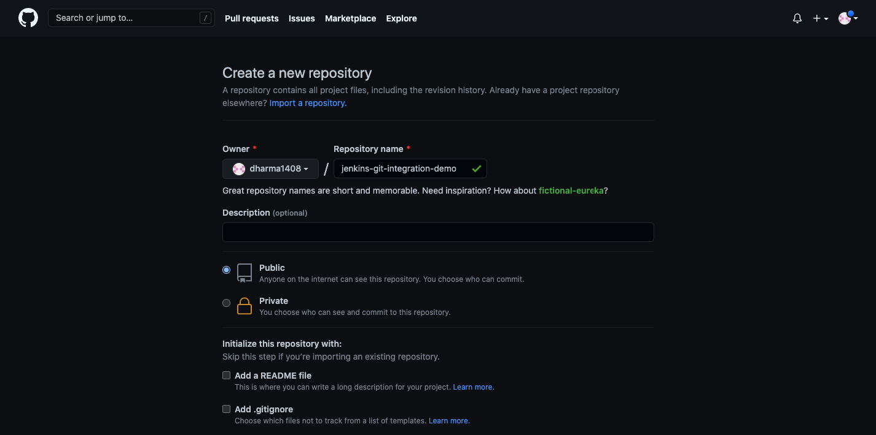

**Step 4: Connect a GitHub Repository**

Scroll down to the “Pipeline” section. We will configure Jenkins to use GitHub repository as source. Select “Pipeline Script from SCM” under the definition option.

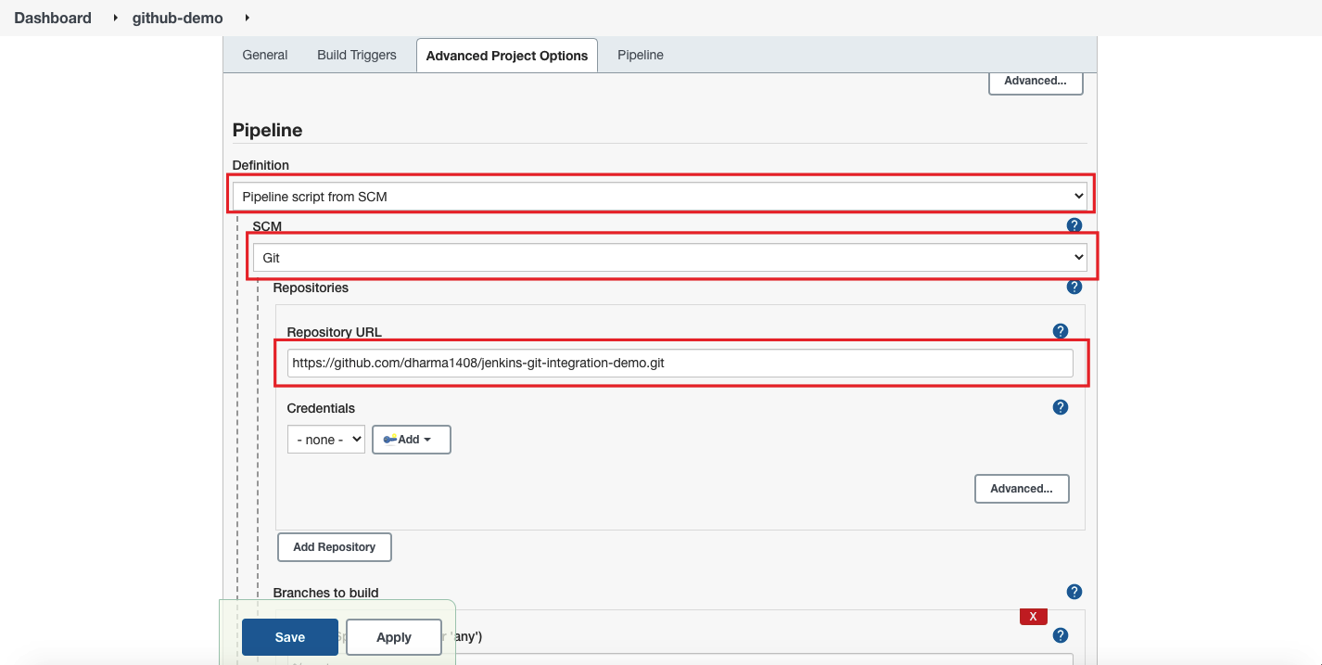

Type the Jenkinsfile path and click on save.

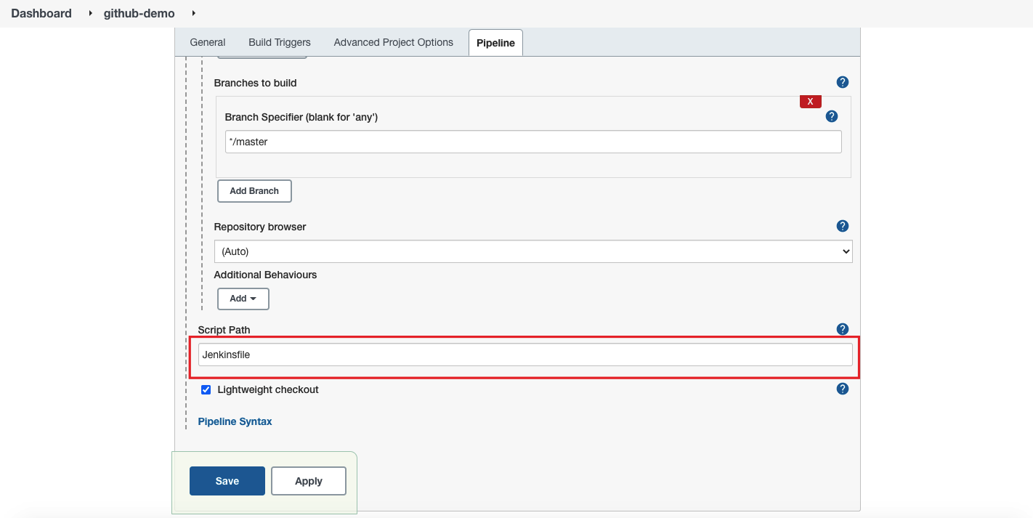

**Step 5: Adding a WebHook in GitHub**

Login to GitHub and go to the repository which you have connected in the previous step.

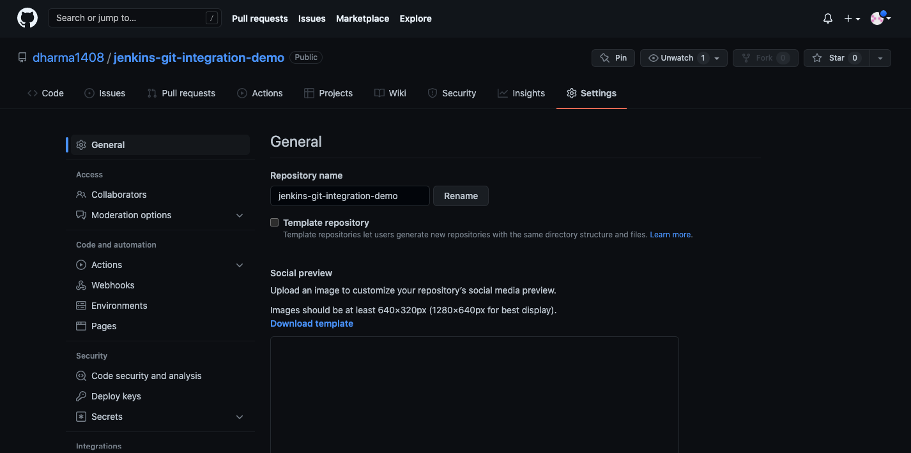

Click on “WebHooks” and then click on “Add WebHooks”.

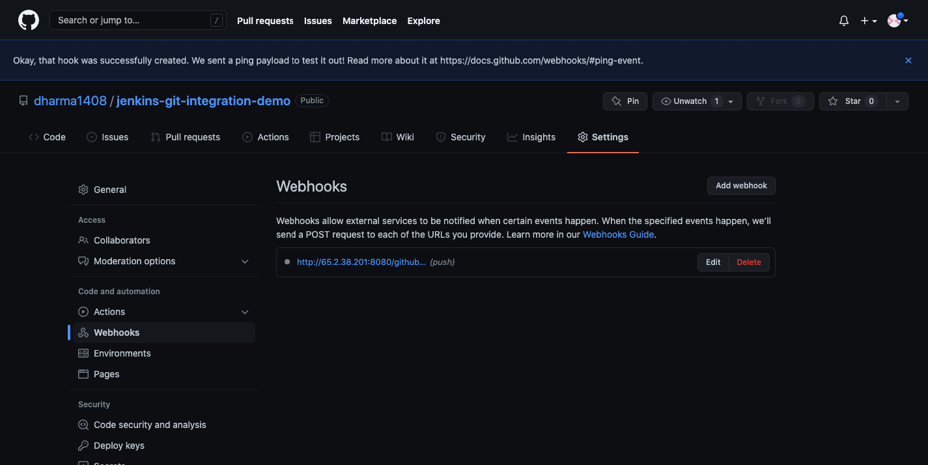

**Step 6: Manually Building Jenkins Job**

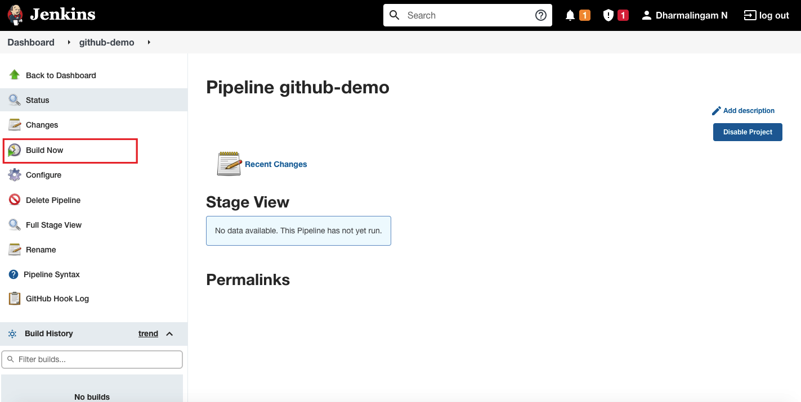

• Build a pipeline using script in Jenkins

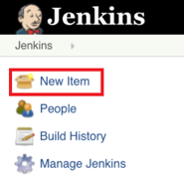

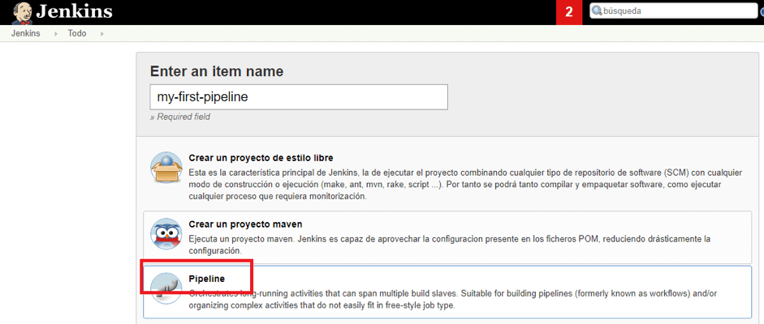

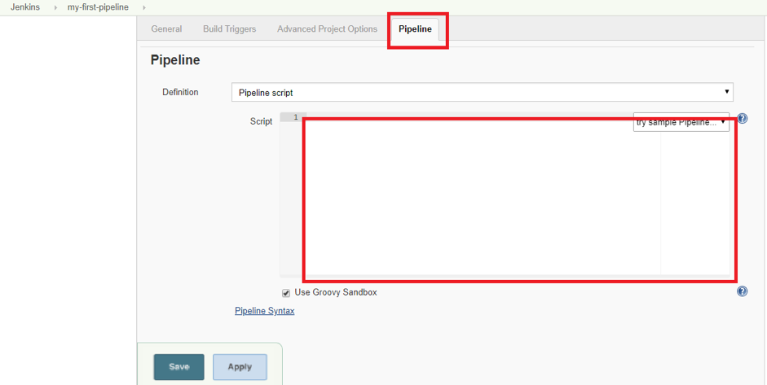

**Creating Your Jenkins Pipeline Script**

 .

**Node Blocks**

The first block to be defined is the “node”:

node {

}

**Stage Blocks**

The next required section is the “stage”:

stage {

}

node {

stage (‘Build’) {

bat "msbuild ${C:\\Jenkins\\my_project\\workspace\\test\\my_project.sln}"

}

stage('Selenium tests') {

dir(automation_path) { //changes the path to “automation_path”

bat "mvn clean test -Dsuite=SMOKE_TEST -Denvironment=QA"

}

}

}

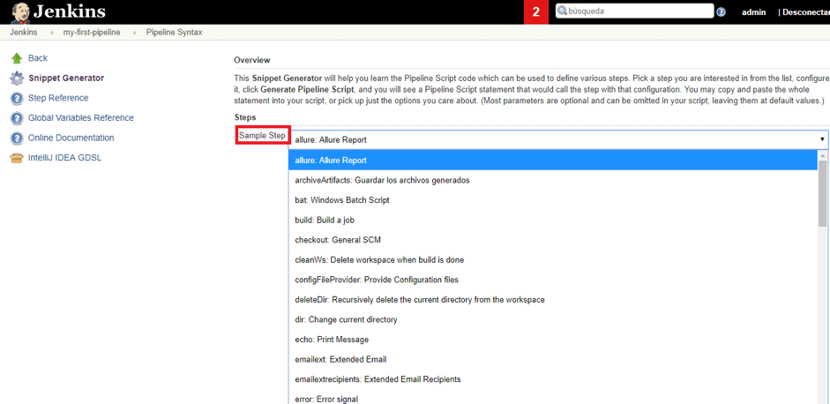

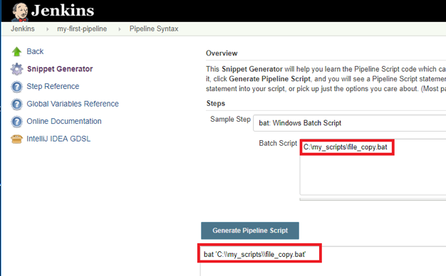

**PRACTICAL 13 : Background study, Installation and configuration of Docker on windows/**

**Linux platform /using play with docker platform**

Docker is an **open-source centralized platform designed** to create, deploy, and run applications. Docker uses **container** on the host's operating system to run applications. It allows applications to use the same **Linux kernel** as a system on the host computer, rather than creating a whole virtual operating system. Containers ensure that our application works in any environment like development, test, or production.

Docker includes components such as **Docker client, Docker server, Docker machine, Docker hub, Docker composes,** etc.

Let's understand the Docker containers and virtual machine.

Docker Containers

Docker containers are the **lightweight** alternatives of the virtual machine. It allows developers to package up the application with all its libraries and dependencies, and ship it as a single package. The advantage of using a docker container is that you don't need to allocate any RAM and disk space for the applications. It automatically generates storage and space according to the application requirement.

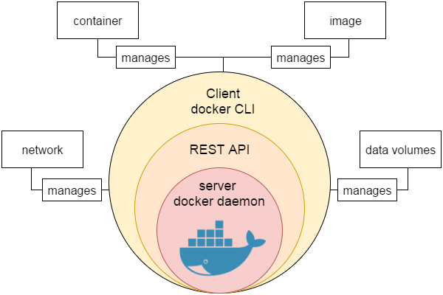

## **Docker for Windows**

Once the installer has been downloaded, double-click it to start the installer and then follow the steps given below.

**Step 1** − Click on the Agreement terms and then the Install button to proceed ahead with the installation.

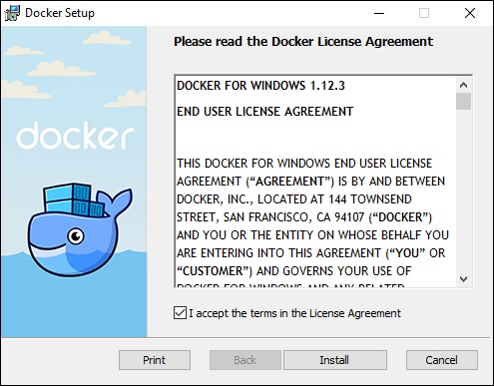

**Step 2** − Once complete, click the Finish button to complete the installation.

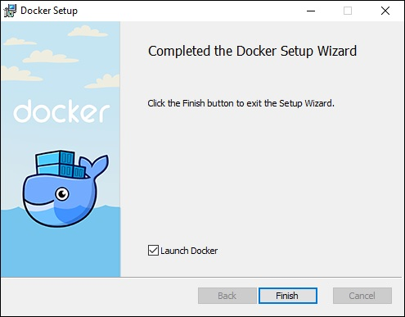

## **Docker ToolBox**

Once the installer has been downloaded, double-click it to start the installer and then follow the steps given below.

**Step 1** − Click the Next button on the start screen.

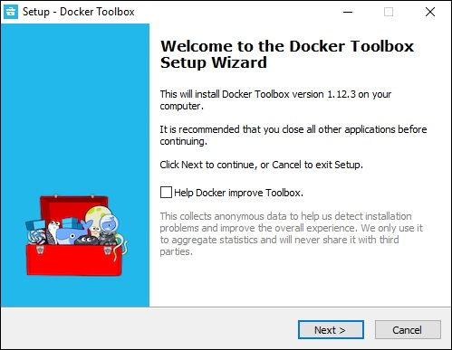

**Step 2** − Keep the default location on the next screen and click the Next button.

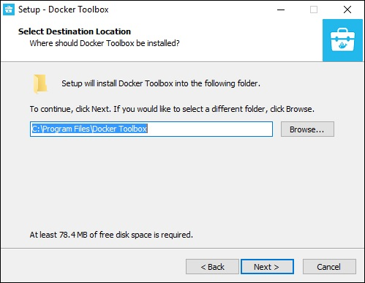

**Step 3** − Keep the default components and click the Next button to proceed.

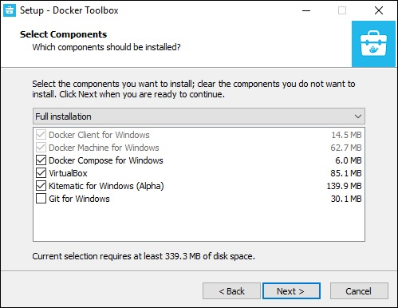

**Step 4** − Keep the Additional Tasks as they are and then click the Next button.

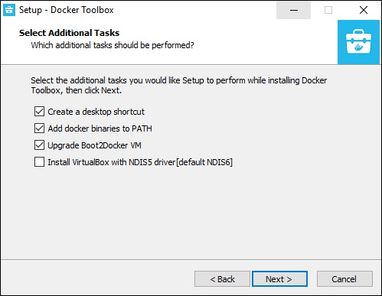

**Step 5** − On the final screen, click the Install button.

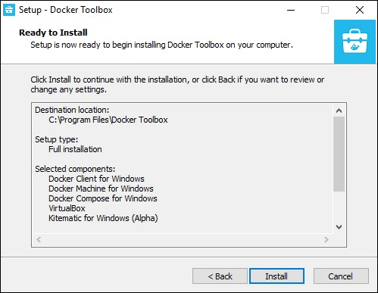

## **Working with Docker Toolbox**

Let’s now look at how Docker Toolbox can be used to work with Docker containers on Windows. The first step is to launch the Docker Toolbox application for which the shortcut is created on the desktop when the installation of Docker toolbox is carried out.

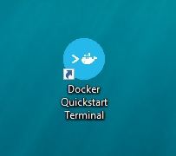

Next, you will see the configuration being carried out when Docker toolbox is launched.

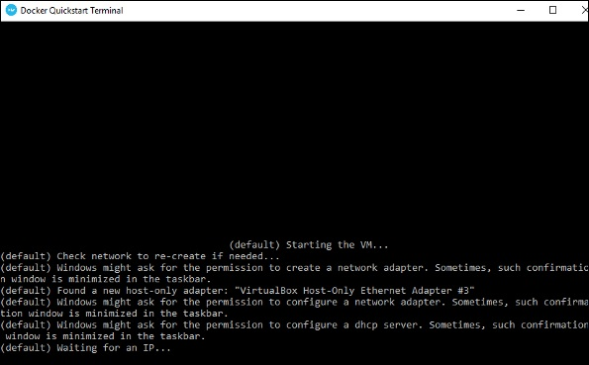

Once done, you will see Docker configured and launched. You will get an interactive shell for Docker.

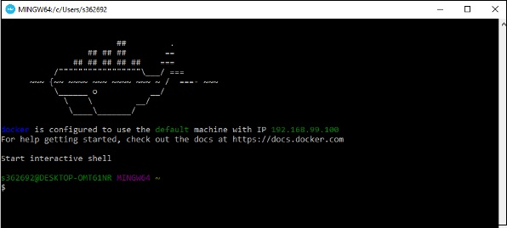

To test that Docker runs properly, we can use the Docker **run command** to download and run a simple **HelloWorld Docker container**.

**PRACTICAL 14: Execute Docker Basic Commands(with snapshots):-**

• docker images

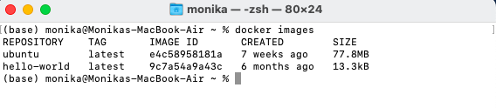

• docker pull

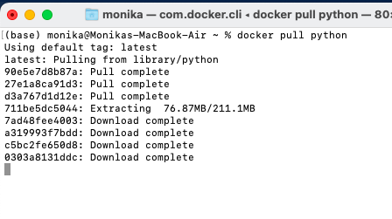•

docker run

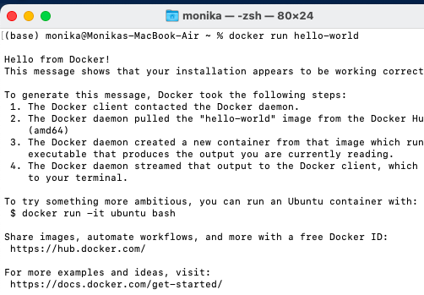

• docker ps (with flags such as -a, -l, -q)

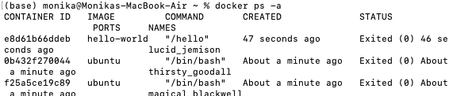



• docker stop (for single or multiple containers)

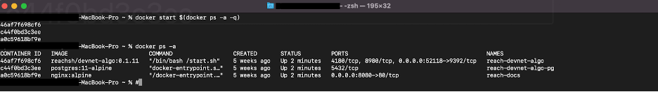

• docker rm(with flags such as -f, -v, -l)

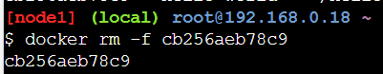

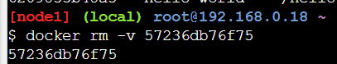

• docker commit

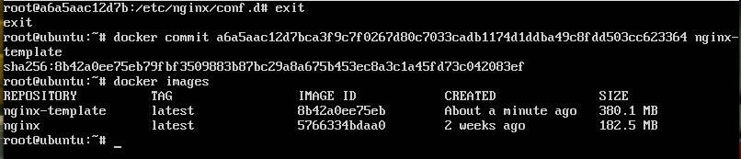

**PRACTICAL -15: Execute following Docker Image Commands(with relevant snapshots):-**

• docker build command

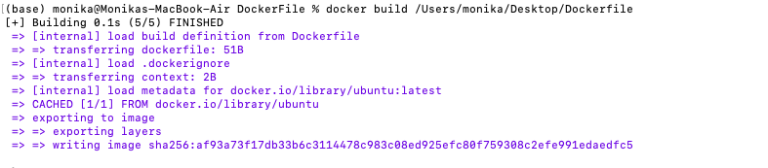

• docker pull command

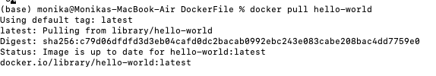

• docker images command

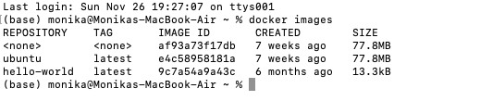

• docker inspect command

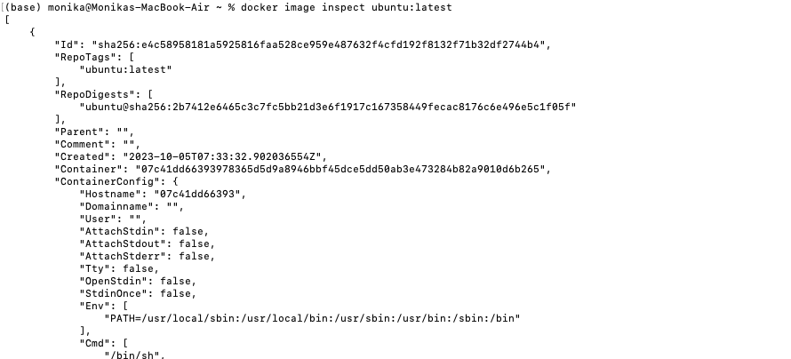

• docker push command

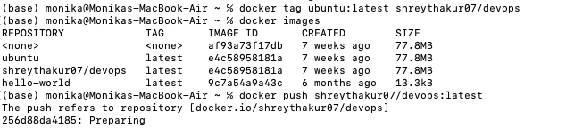

• docker save command

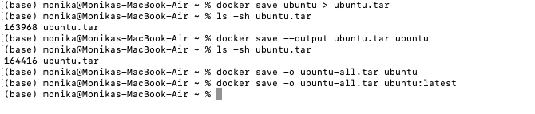

• docker rmi command

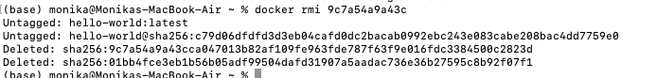

**Practical -16 Design Docker container life cycle and execute following Docker Container**

**Commands(with relevant snapshots):-**

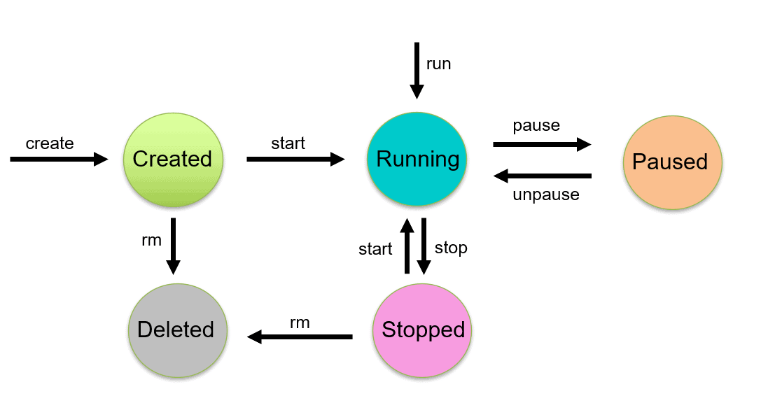

• docker attach

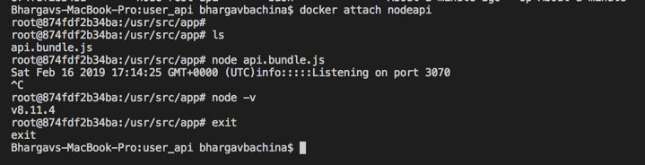

• docker ps command





• docker start and restart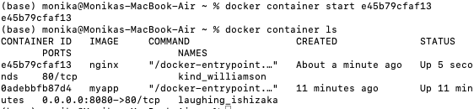

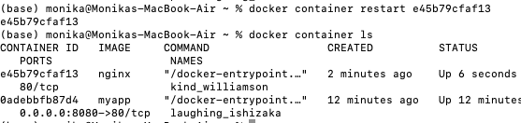

• docker port mapping





• docker container command



• docker container inspect infinite Command

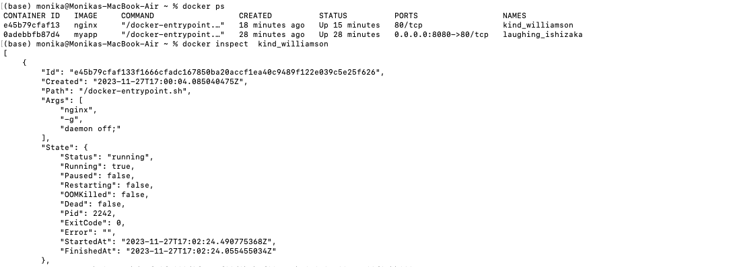

• docker exec command (with flags such as -d, -i, -e)

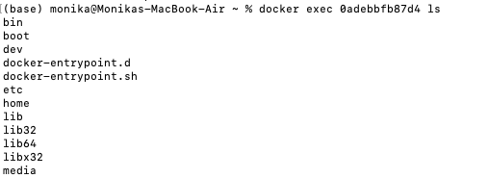

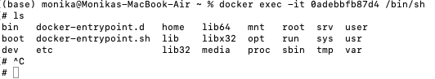

• docker cp command

